**DATA 228: Big Data Technologies and Applications**

**Homework 4: Multi-Region Application**

Pied Piper members: (Bhavik Patel (016800550), Namratha Sampath (016691883), Smeet Sheth (016786133), Sourab Saklecha(016605420), Yuti Khamker(016715283))

Step 1: Register as a metadata developer

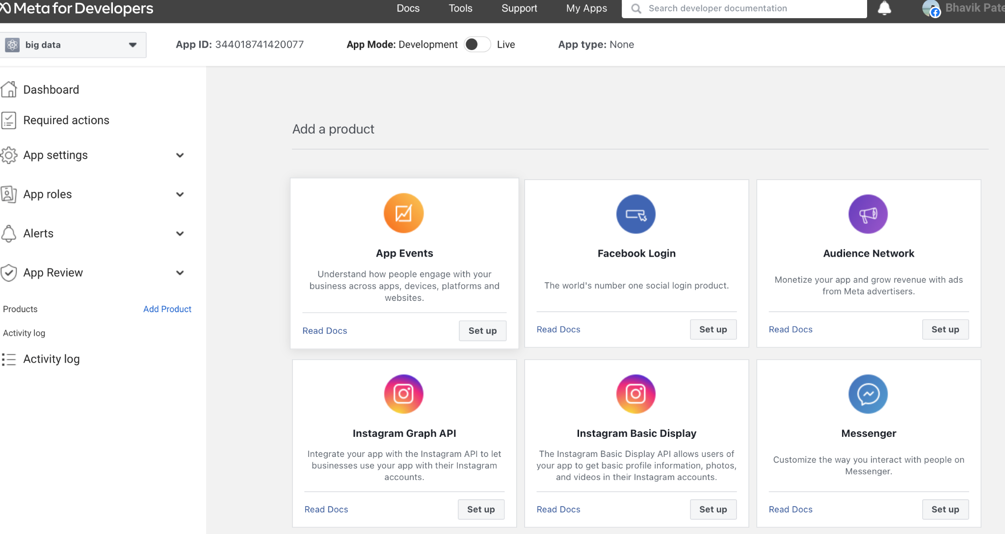

**Figure 1:** Creating app through facebook developers access.

Step 2. Creating AWS cloud9 environment

1. AWS Cloud9 dashboard:

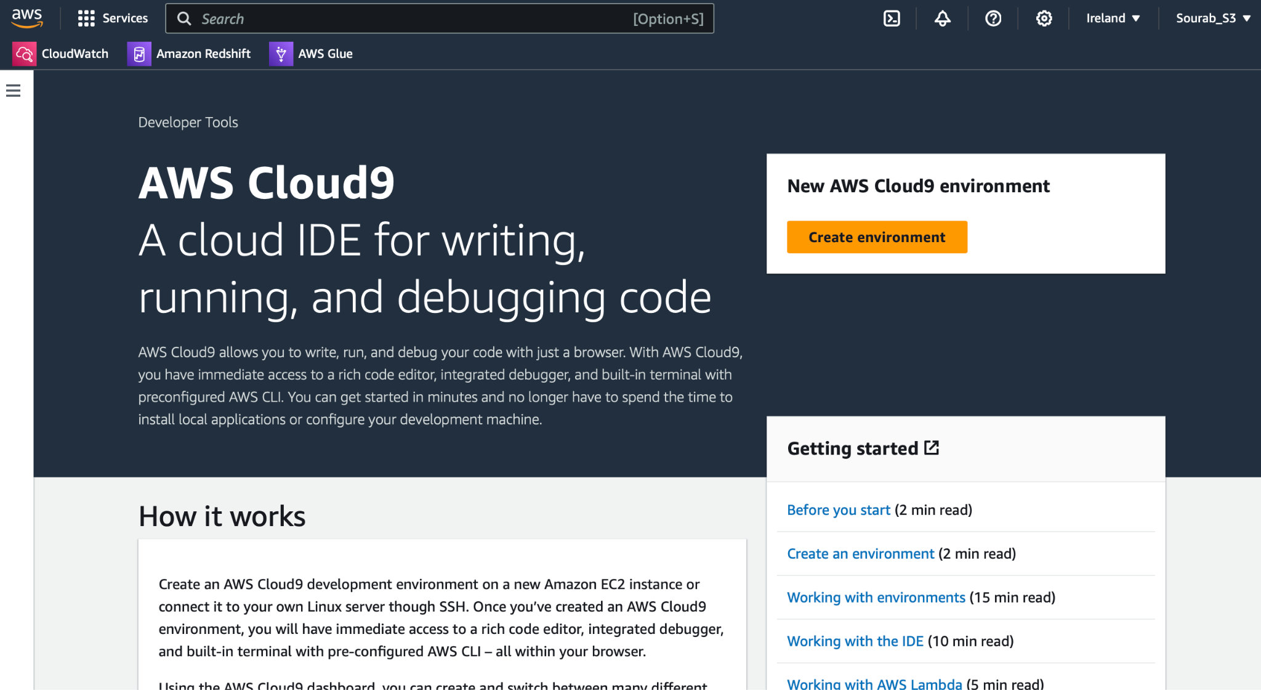

**Figure 2:** Dashboard cloud9 environment

1. AWS Cloud9: arc315 is our cloud environment where we can IDE to run code

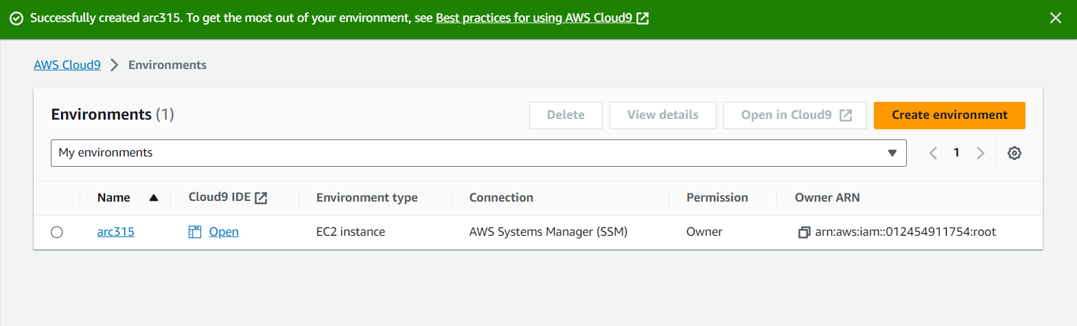

**Figure 3:** successfully created cloud9 environment

1. Checking nvm version, node version, nvm list , and cloning our workshop project

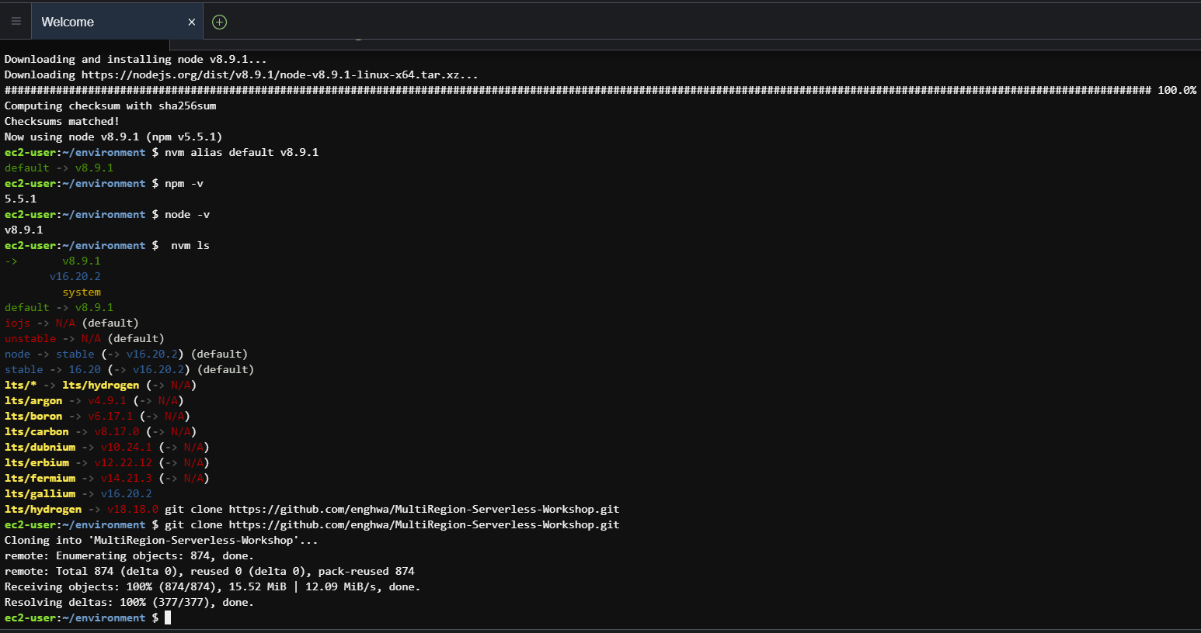

**Figure 4:** Installing required packages and cloning repository

1. Creating IAM policy named “TickedGetPolicy”, “TicketPostPolicy”

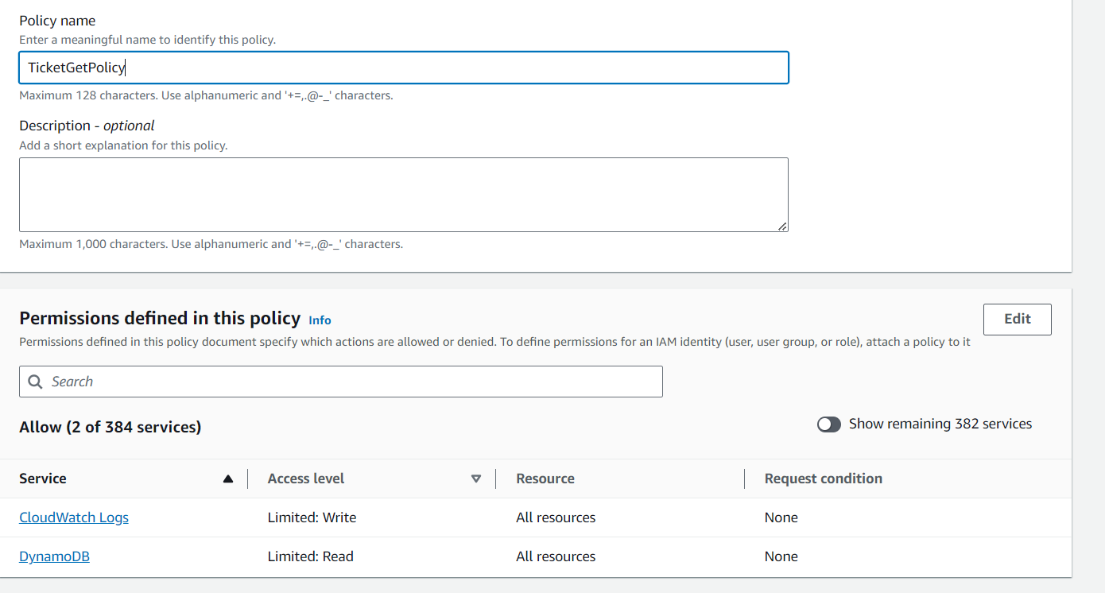

**Figure 5:** Creating custom policy

1. “TickedGetPolicy” created successfully

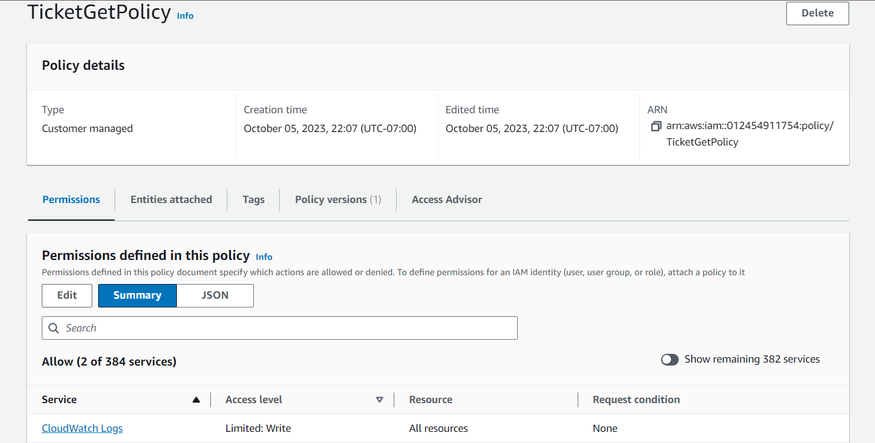

**Figure 6:** Get policy created successfully

1. “TicketPostPolicy” created successfully

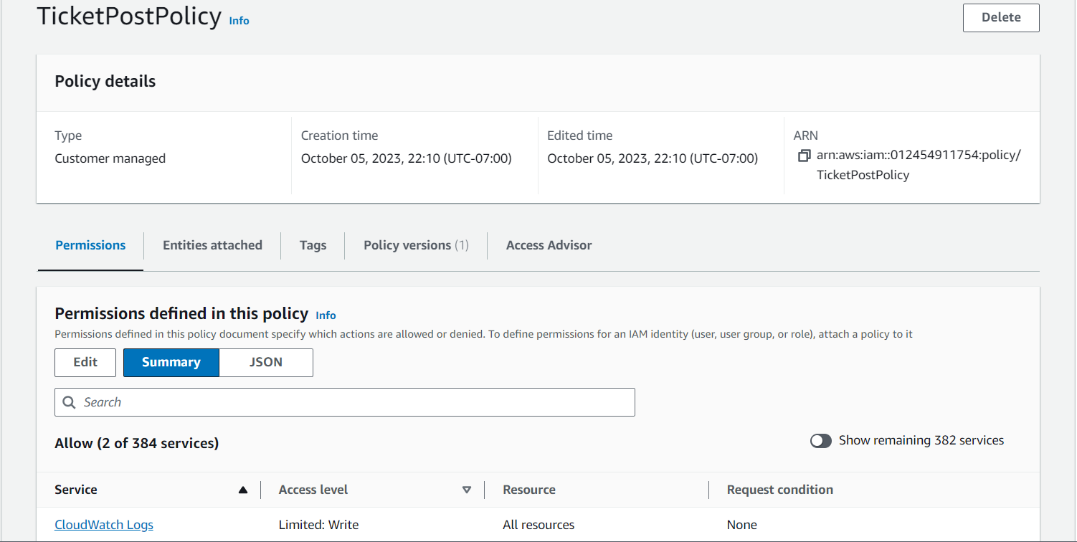

**Figure 7:** Post policy created successfully

1. Creating IAM role selecting lambda for use case

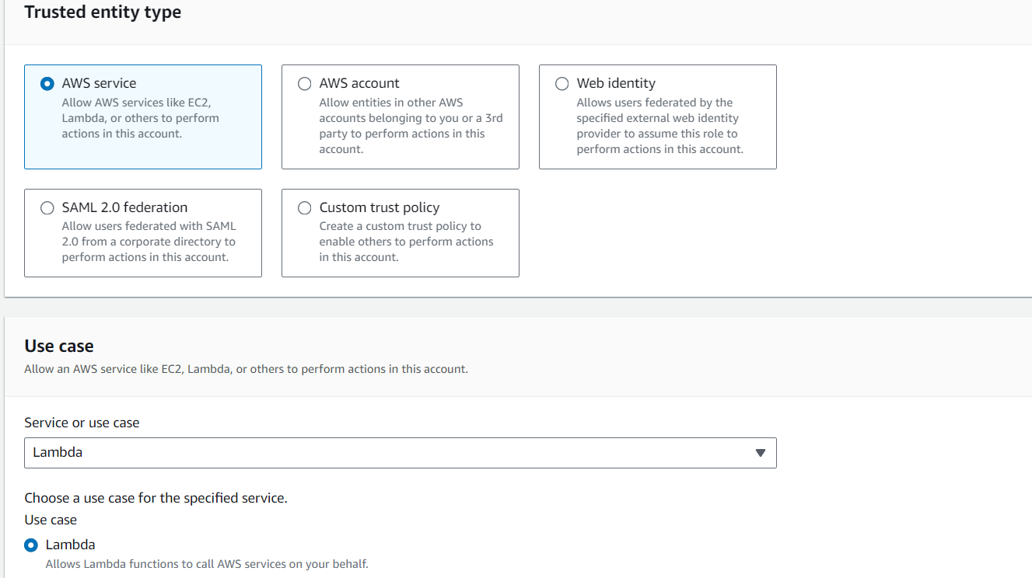

**Figure 8:** configuring IAM role and its use case

1. Now assigning permission (get) to the role

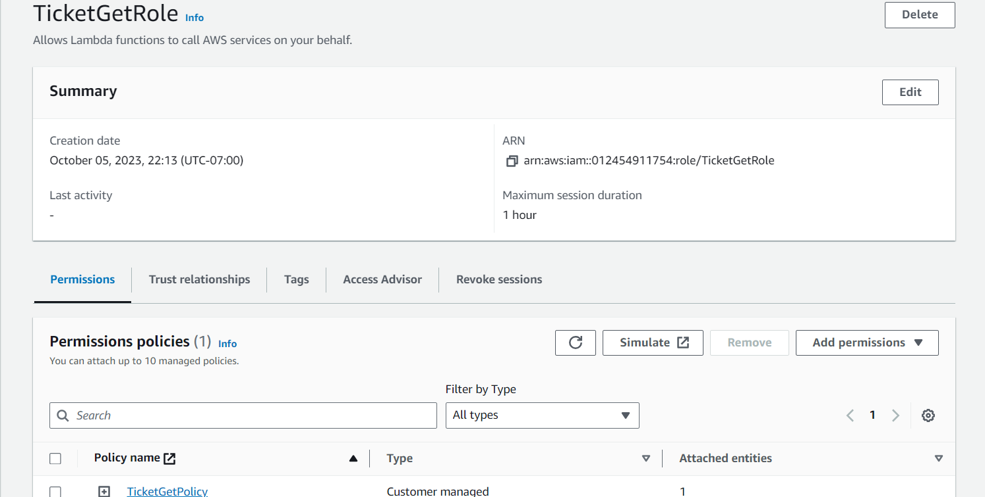

**Figure 9:** assigned permission to “get” role

1. Now assigning permission (post) to the role

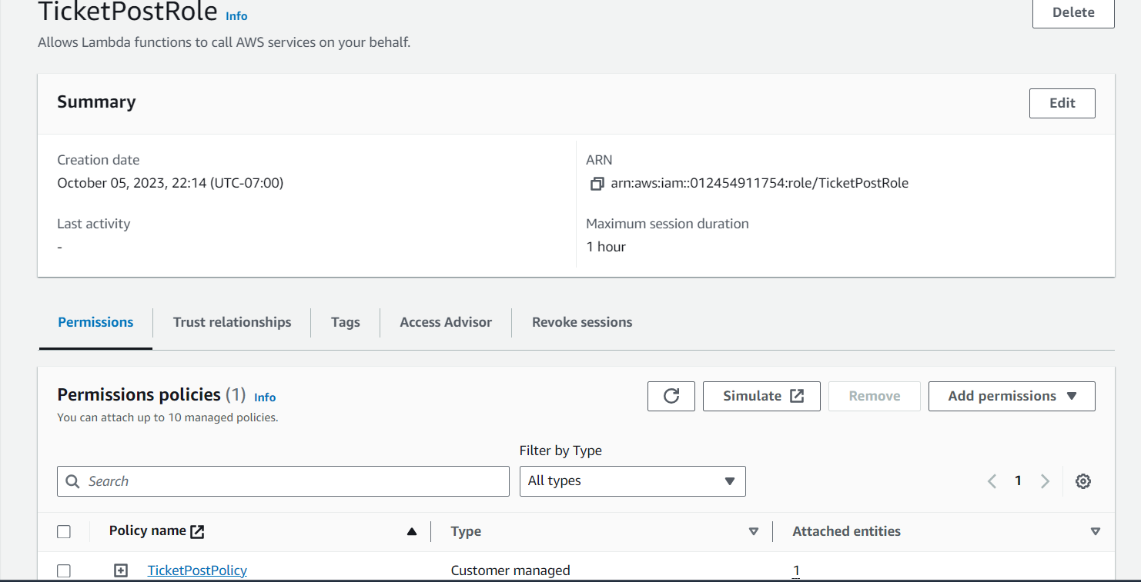

**Figure 10:** assigned permission to “post” role

1. To store our application data we have created table in dynamoDB

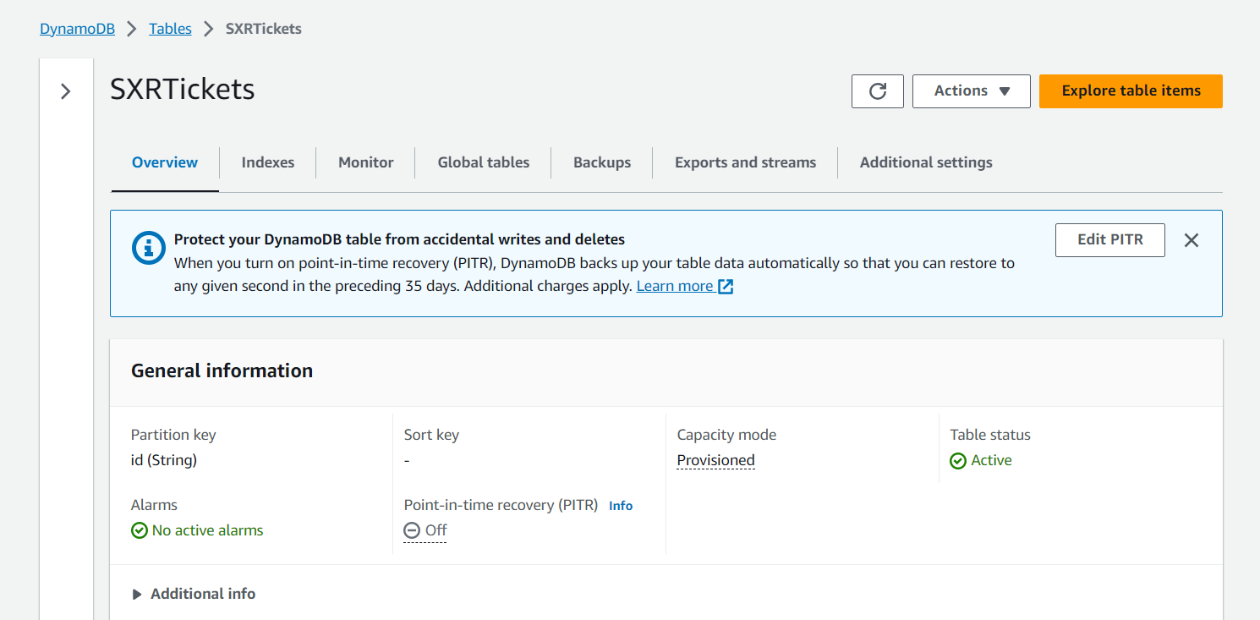

**Figure 11:** SXRTickets is our DB table

1. Creating replica of our application data in Asia Pacific(Singapore) region

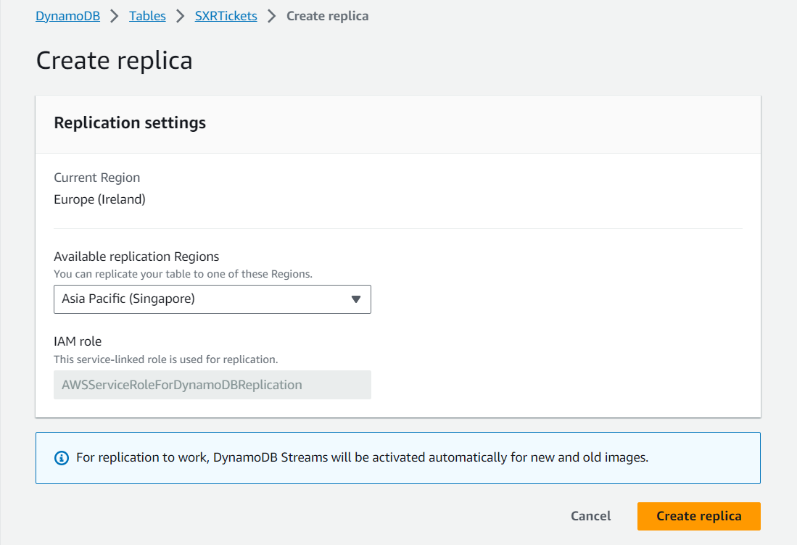

**Figure 12:** Configuring region for replica

1. Successfully created SXRTickets

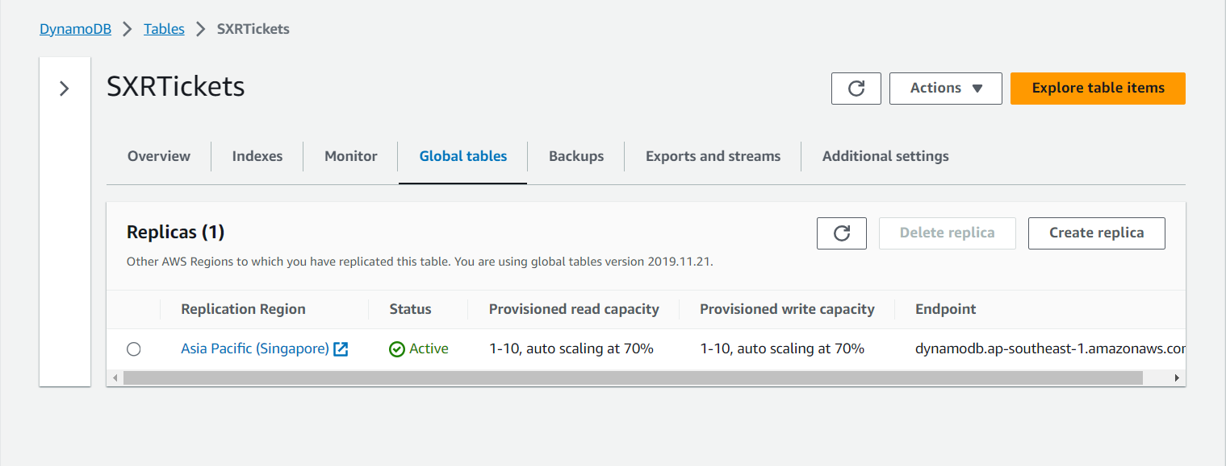

**Figure 13:**  Our table data Replica is created at Singapore successfully

1. Get function is created in Lambda

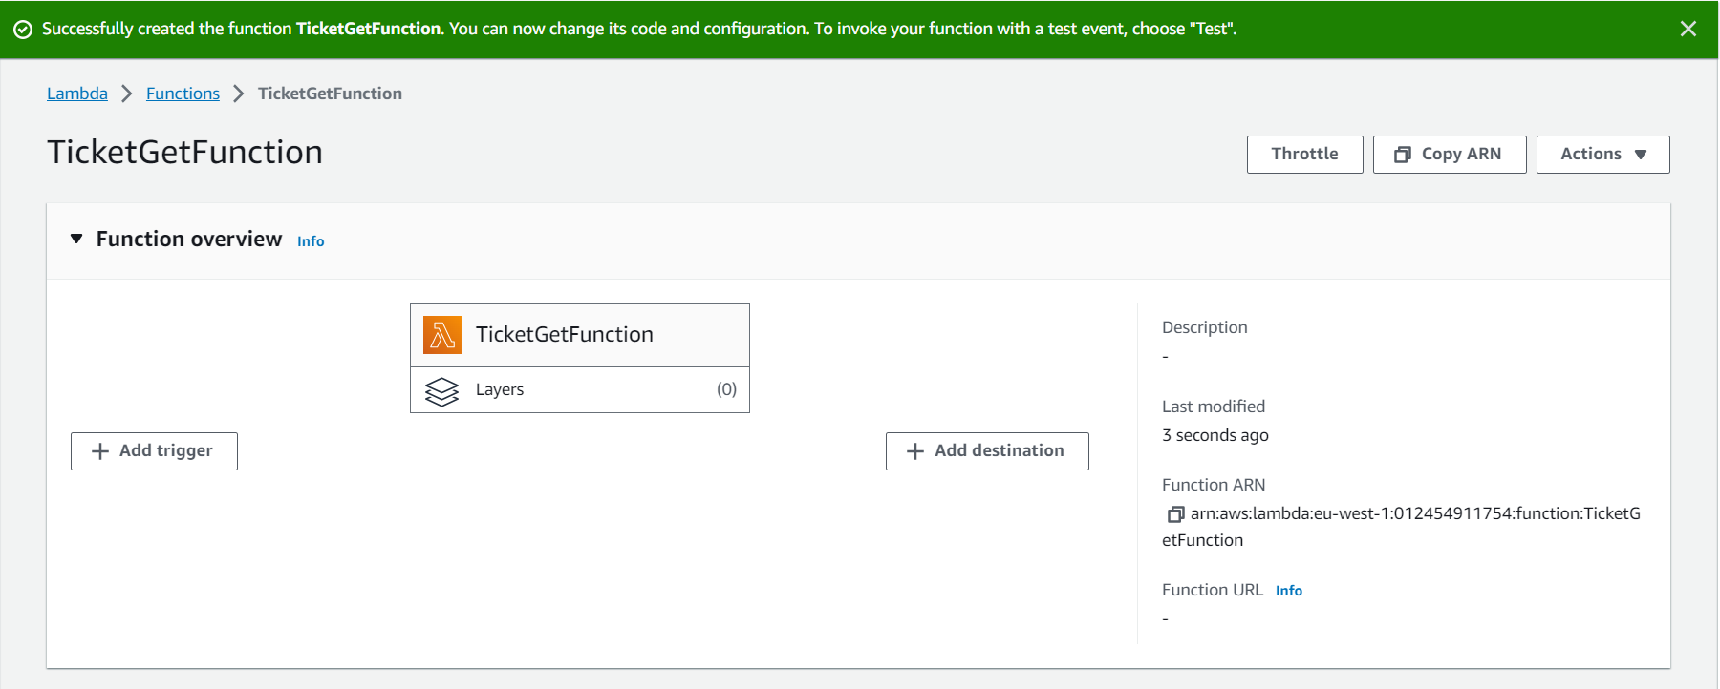

**Figure 14:** Get Function in Lambda

1. Adding environment variable key and value for get function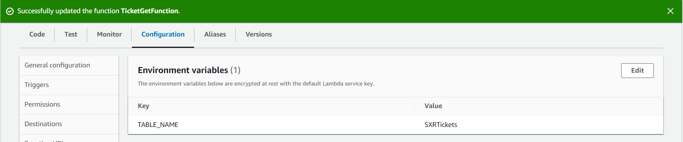

**Figure 15:** Successfully added environment variable for get function

1. Post function is created in Lambda function

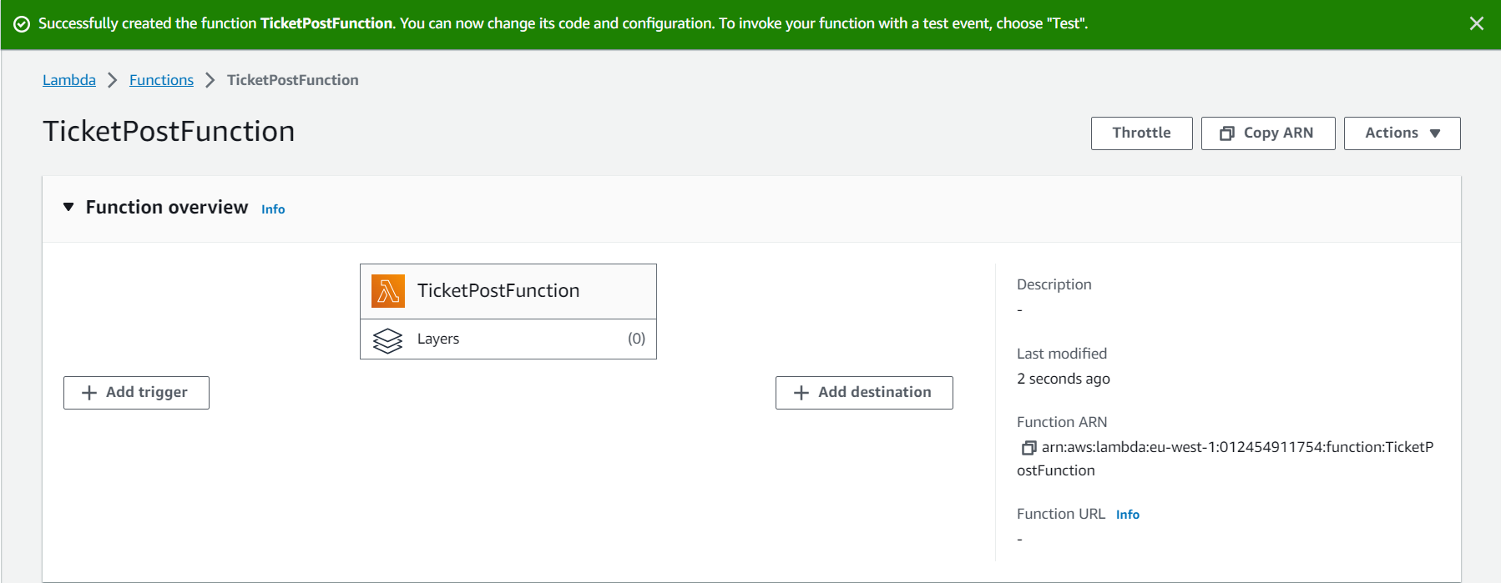

**Figure 16:** Post function in Lambda

1. Adding environment variable key and value for post function

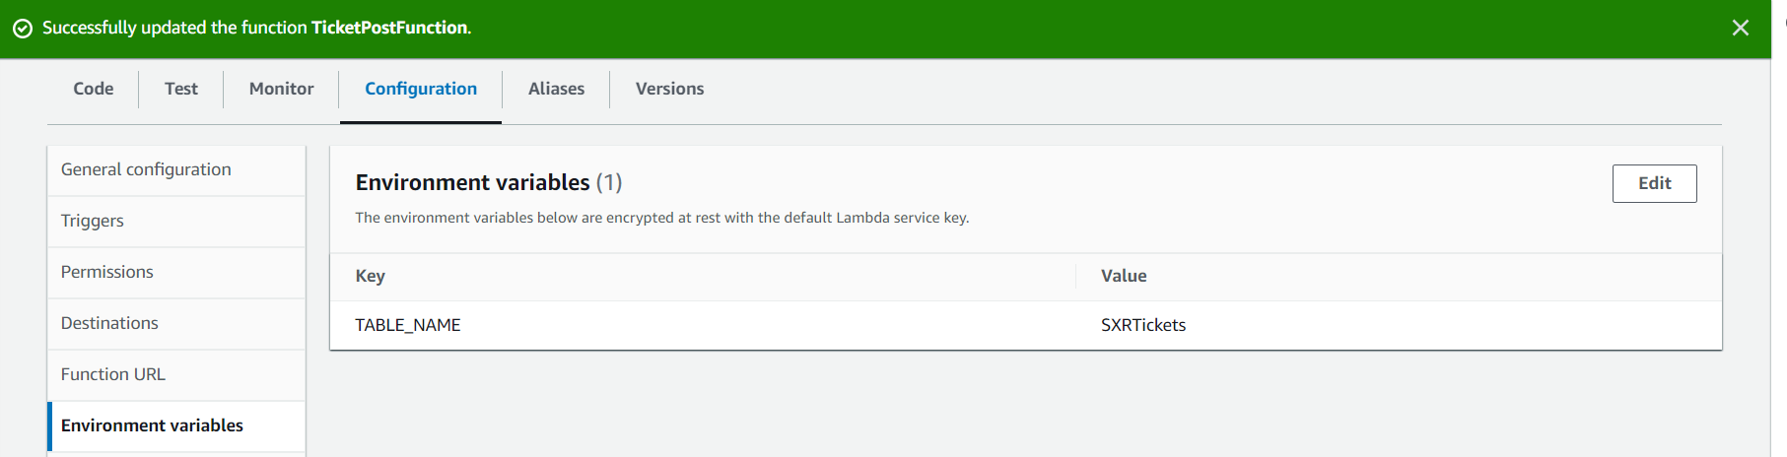

**FIgure 17:** Successfully added environment variable for post function

1. SXRHealthCheck function is created in Lambda function

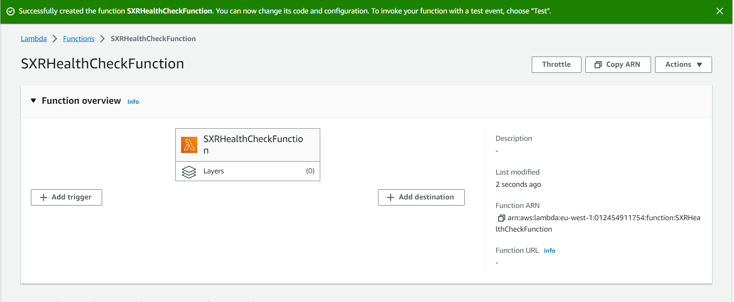

**FIgure 18:** SXRHealthCheck function in Lambda

1. Adding environment variable key and value for post function

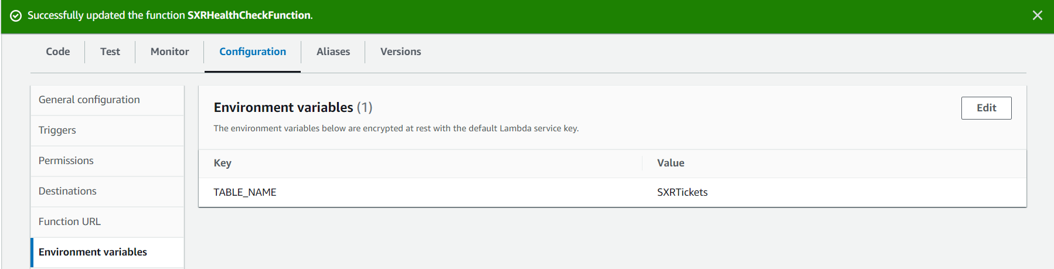

**Figure 19:** Successfully added environment variable for SXRHealthCheck function

1. Creating REST API, choosing api name and endpoint type

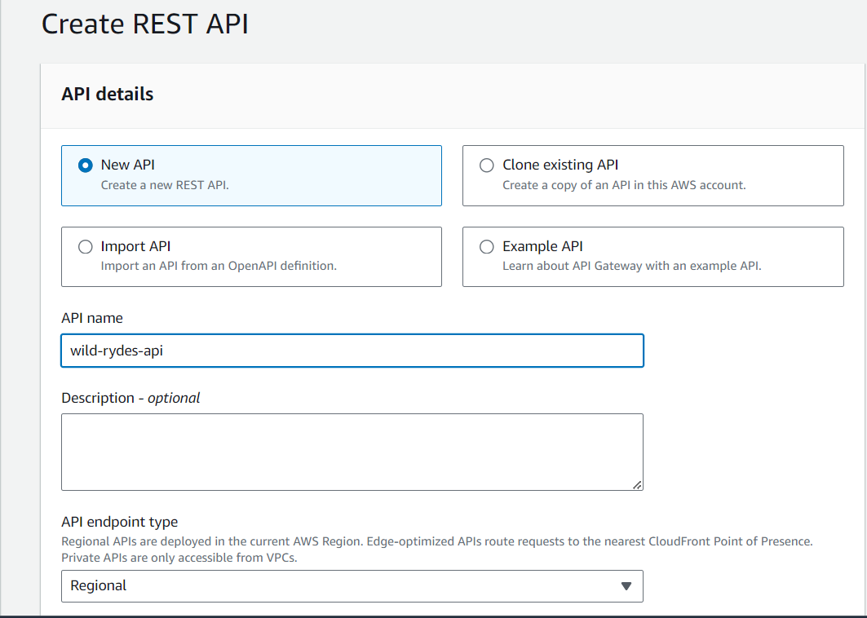

**Figure 20:** Configuring API

1. Creating two resources: health and ticket in API gateway

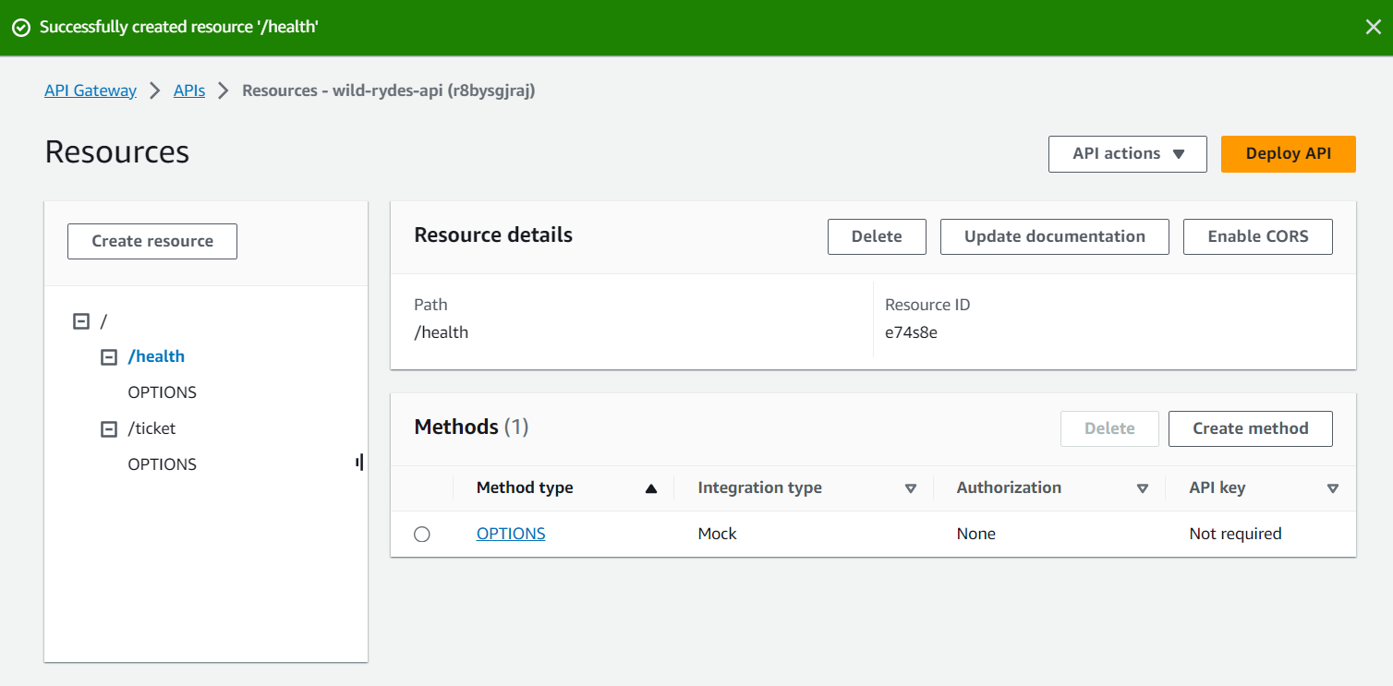

**Figure 21:** Two resources are added in our API

1. Creating get and post methods for health and ticket resources

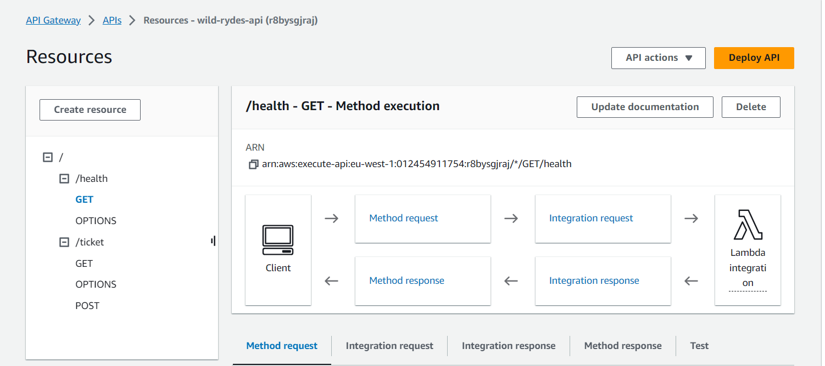

**Figure 22:** Successfully created methods in our resources

1. We created a stage that represents a hierarchical structure which stores resources and methods for each resource.

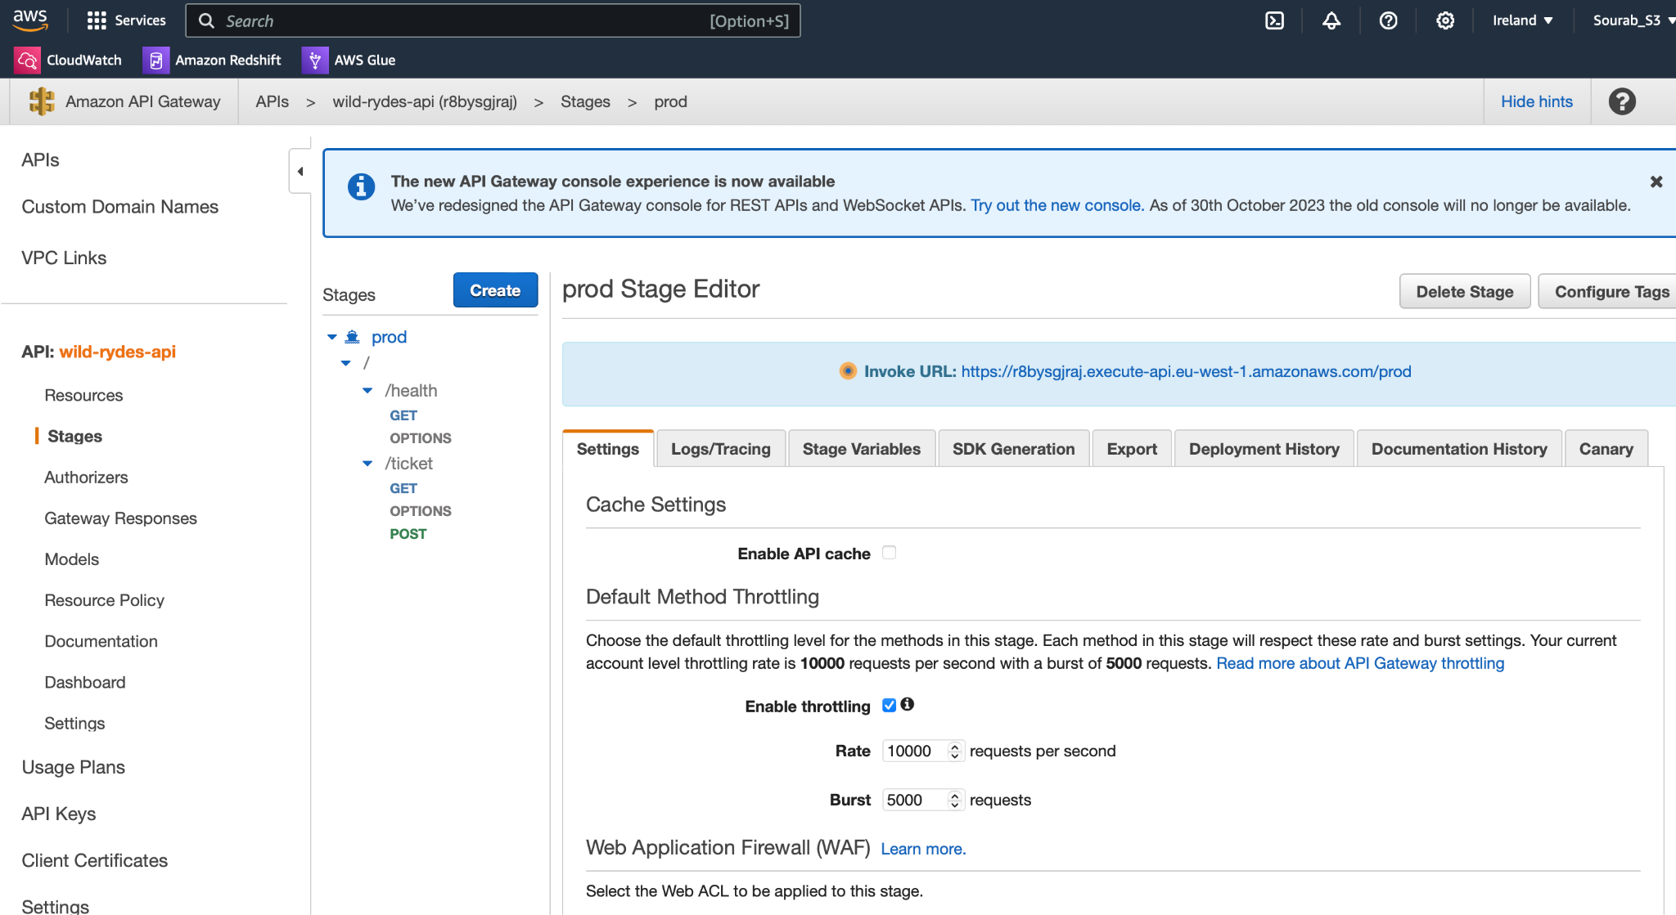**Figure 23:** Hierarchical structure of our Ireland API

1. API gateway Post method

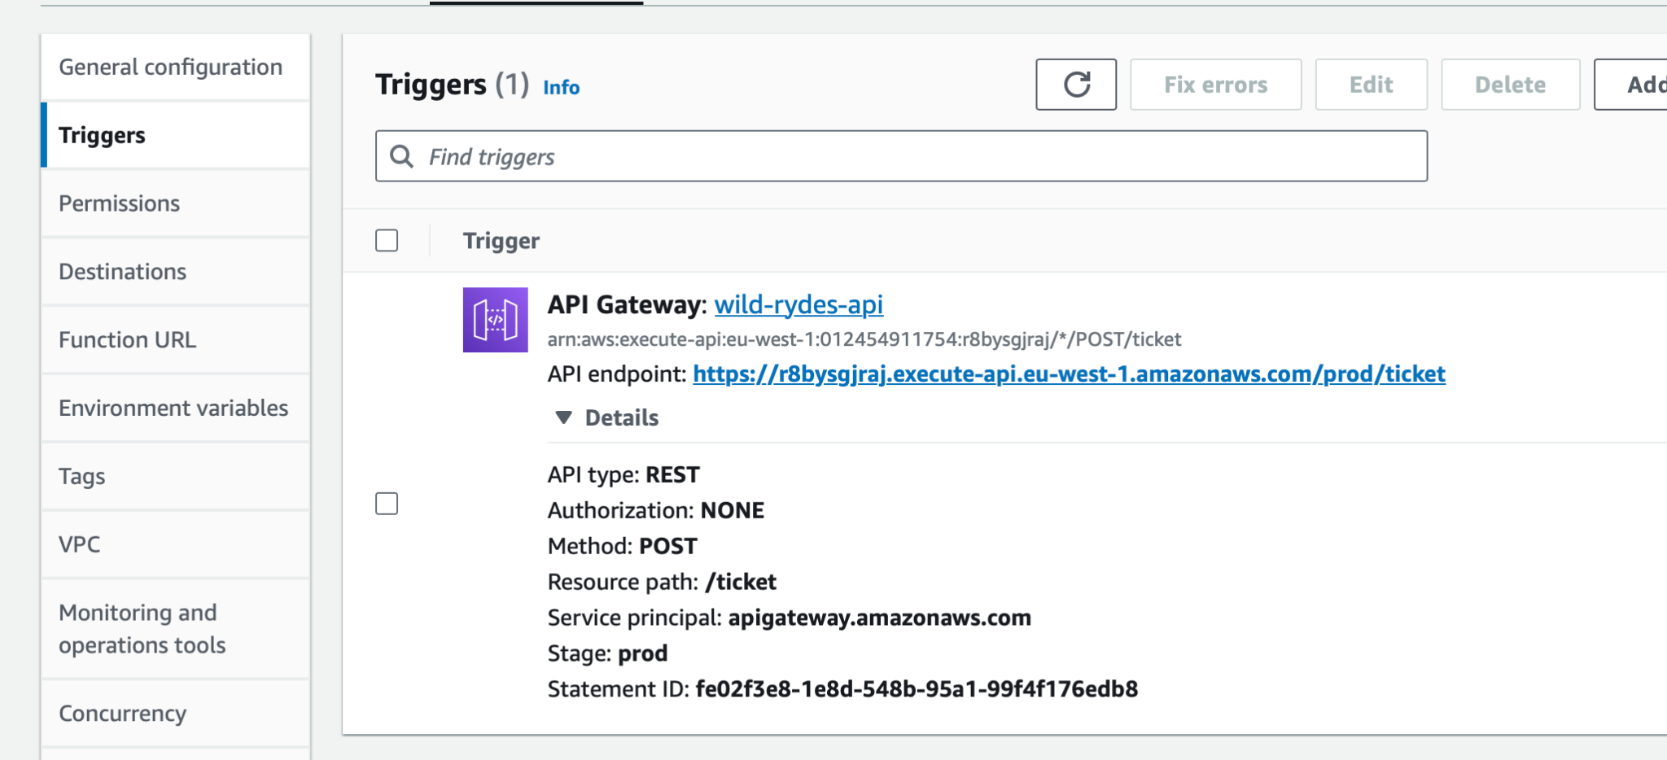

**Figure 24:** API endpoint for post method

1. Result of API

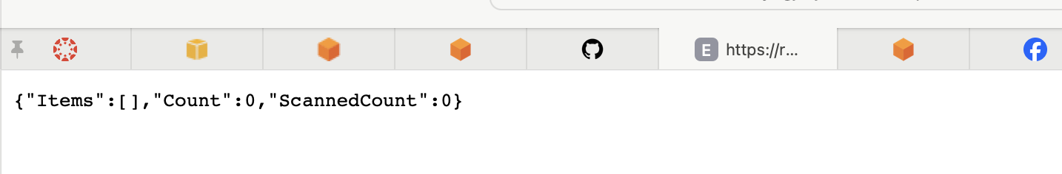

**Figure 25:** Successful execution of API

1. API gateway Post method

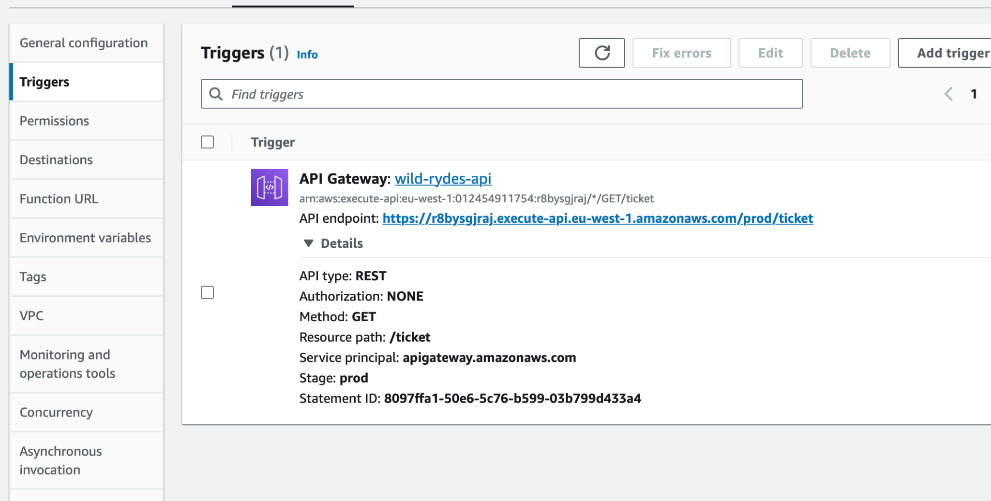

**Figure 26:** API endpoint for get method

1. Result of API

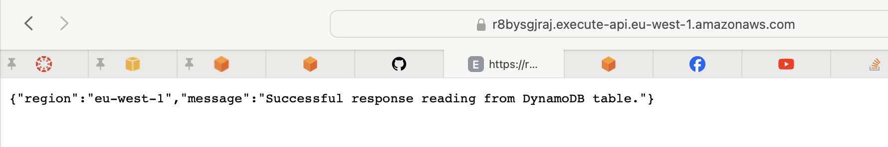

**Figure 27:** Successful execution of API

1. After following steps from 13 to 26, we created APIs, Lambda functions, resources, methods and API getaways for Singapore Region.

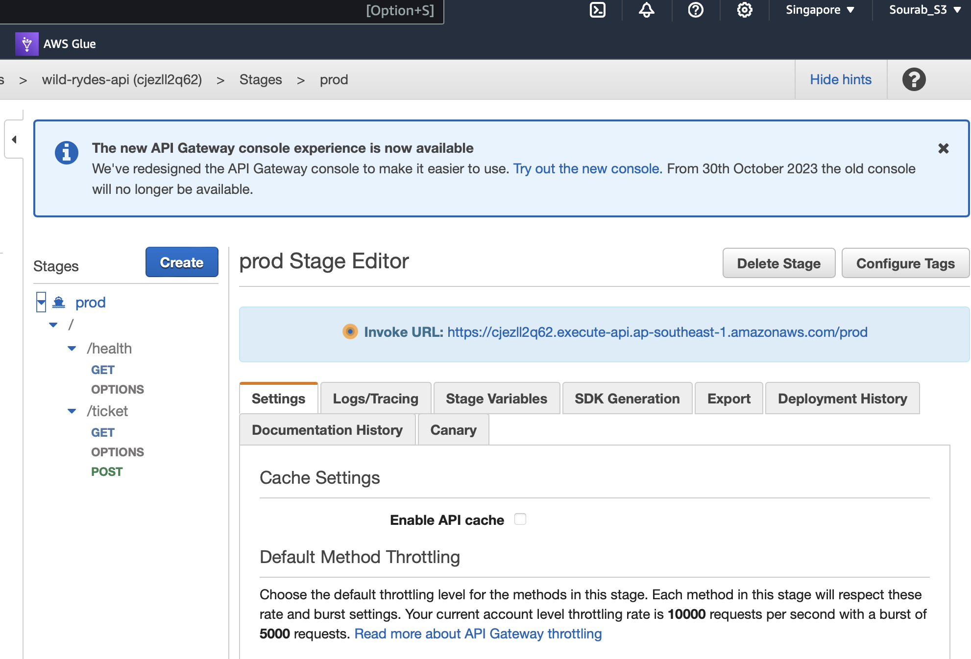

**Figure 28:** Hierarchical structure of our Singapore API

1. Result of Singapore API

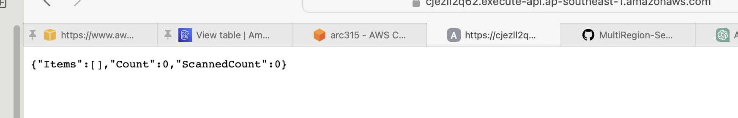

**Figure 29:** Successful execution of API

1. Result of Singapore API

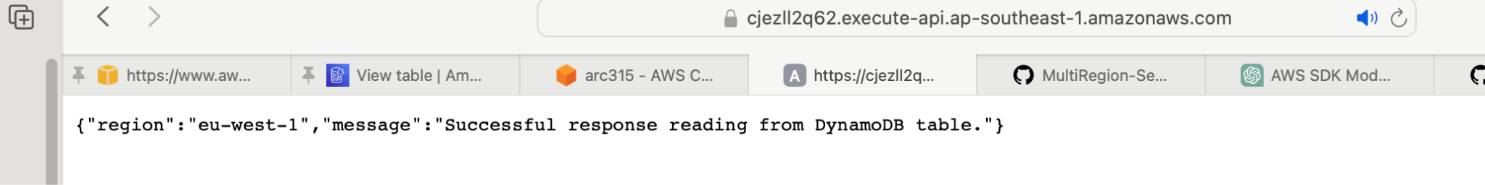

**Figure 30:** Successful execution of API

1. Specifying region, the template file, stack_name “ticket-service-ui” and capabilities of the stack that will be created in CloudFormation

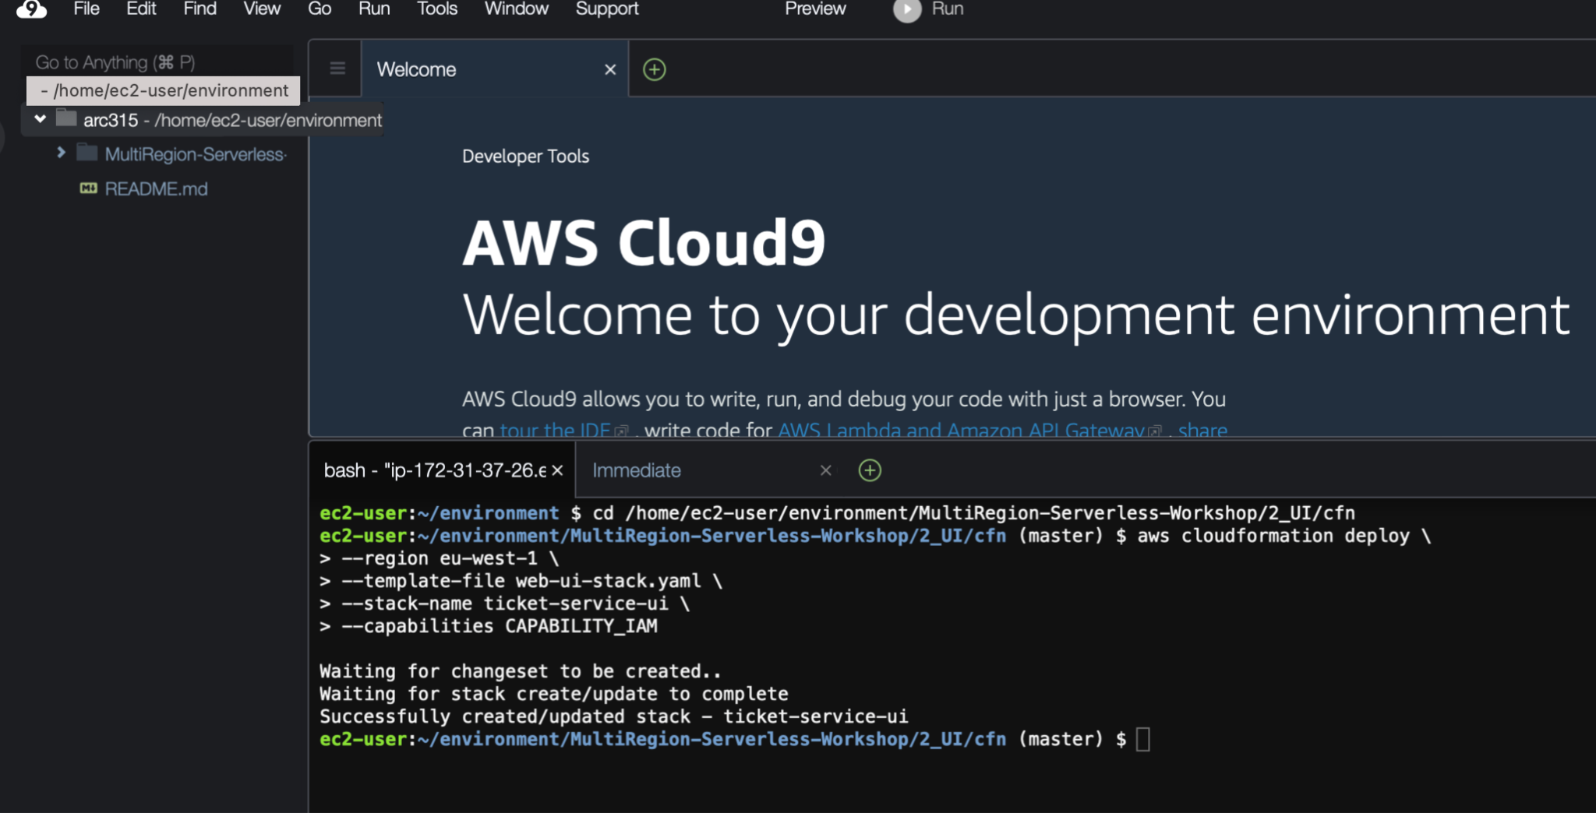

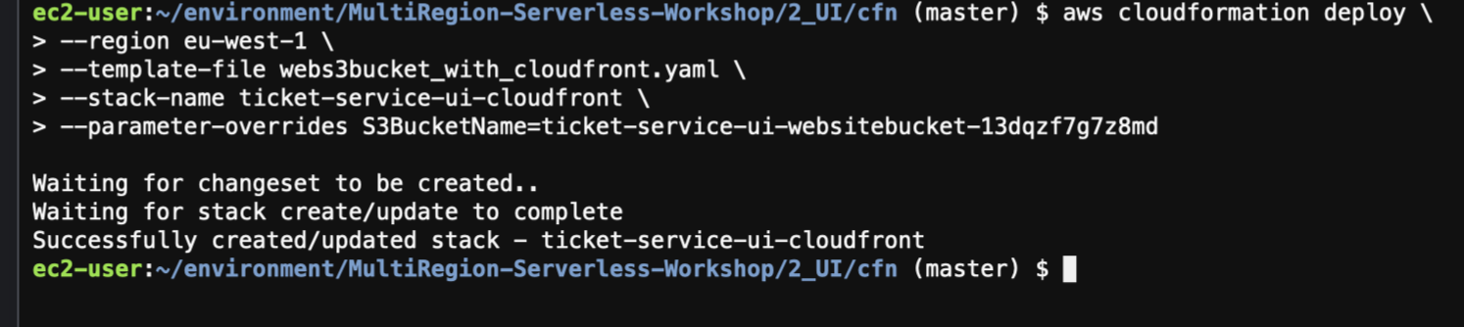

**FIgure 31:**. Creating AWS ID pool and S3 bucket

1. Verifying S3 buckets in AWS S3

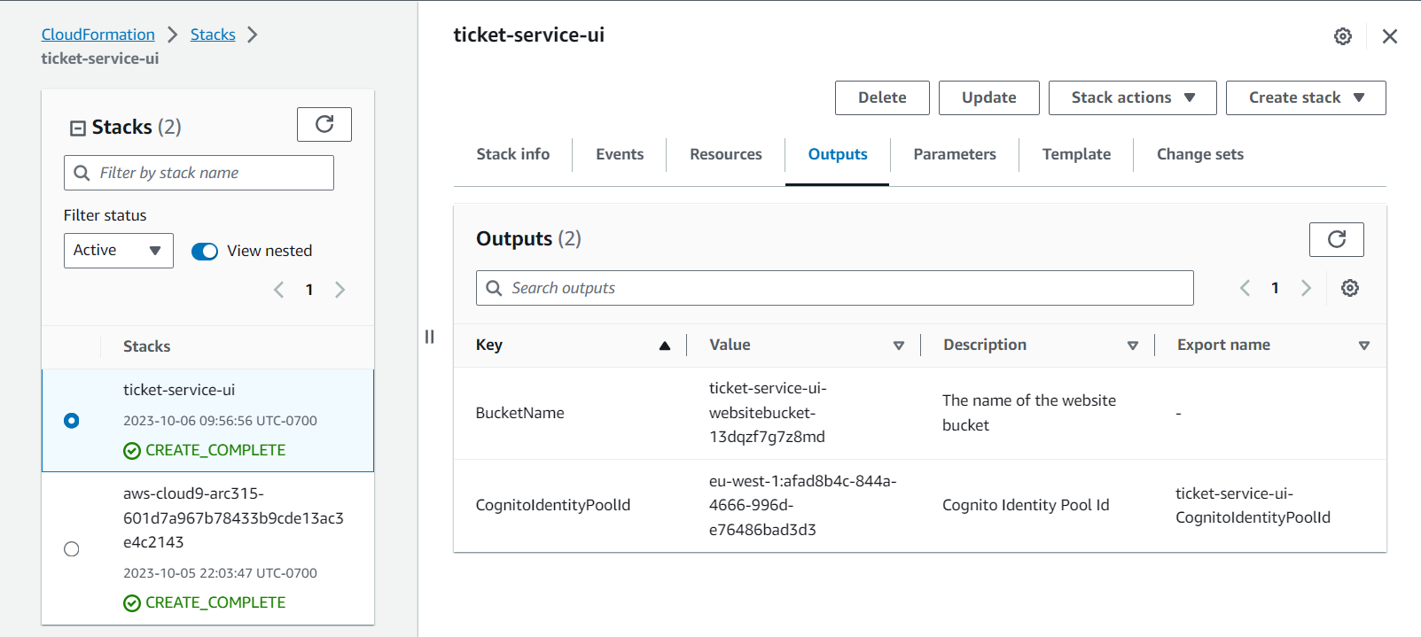

**FIgure 32:** Successfully created stack “ticket-service-ui” in CloudFormation

1. Output showing bucket name, distribution domain name, ID

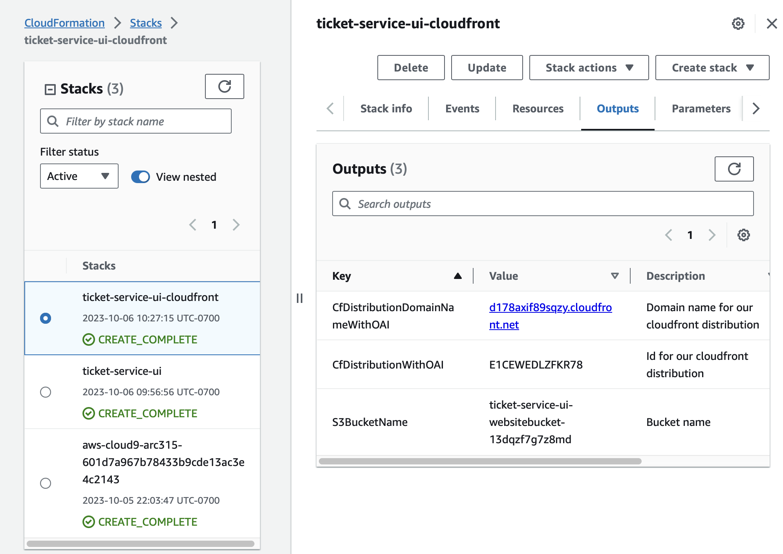

**Figure 33:** Details about bucket in CloudFormation stacks

33. Configuring Facebook as an Identity Provider 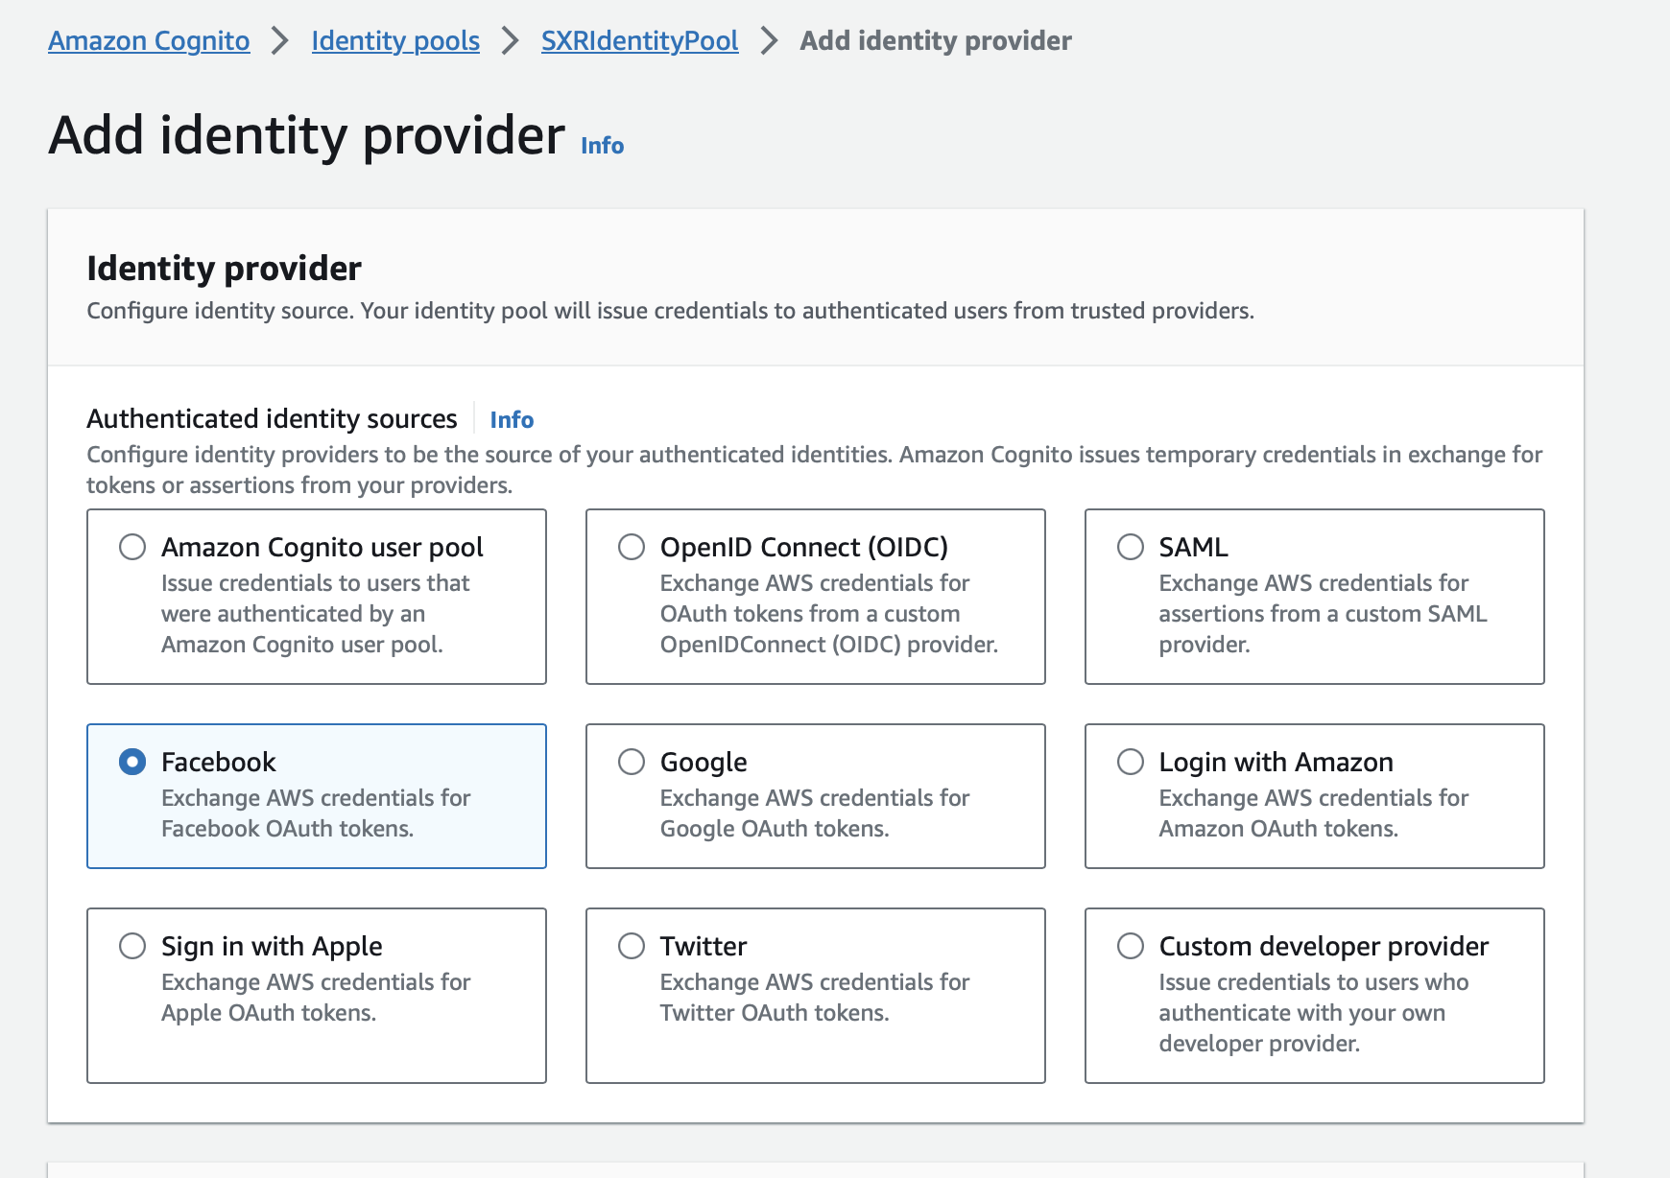

**Figure 34:** Facebook is added as the identity provider

34. The identity provider is successfully added to make it possible for users to log in and use AWS services with their Facebook credentials.

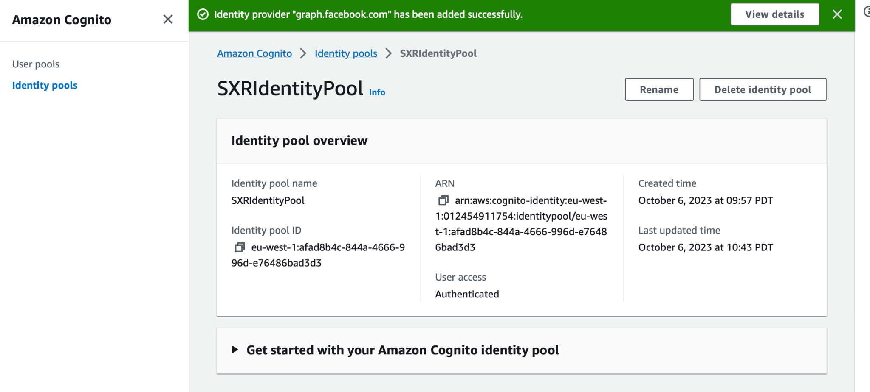

**Figure 35:** An overview of the identity pool

35. Setting up the Root folder and Installing Dependencies

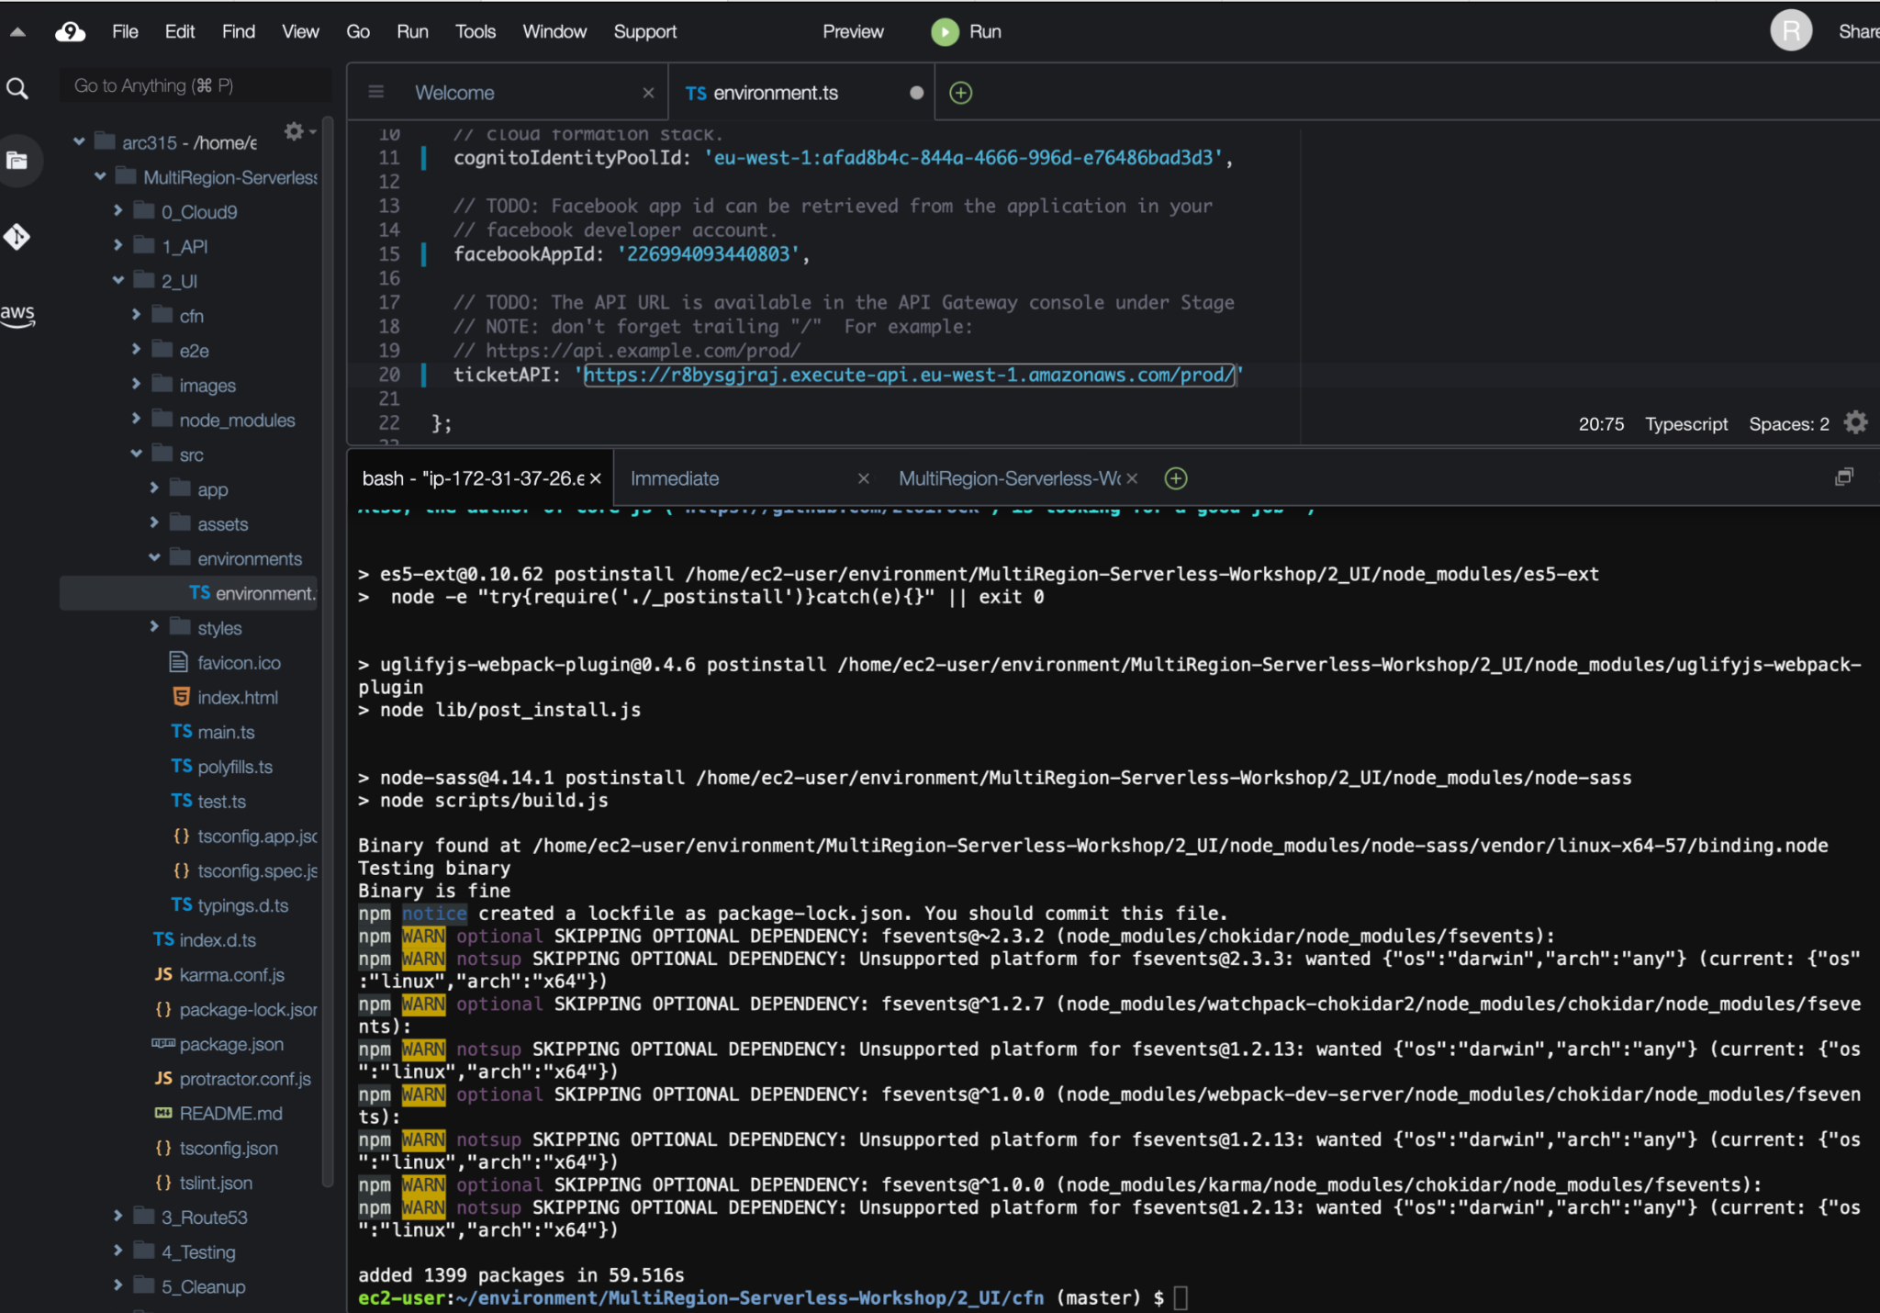

**Figure 36:** Installing necessary dependencies

36. Building our application

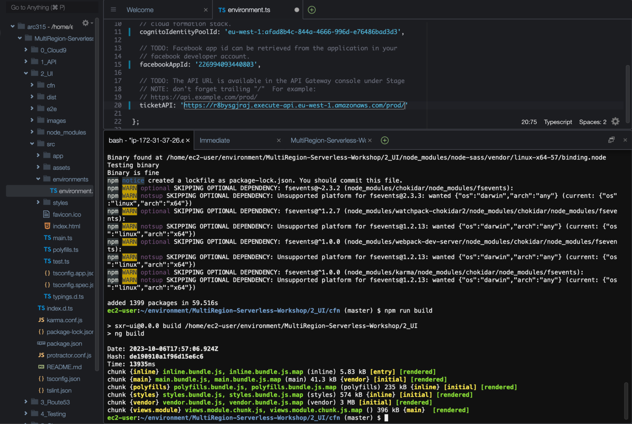

**Figure 37:** Successfully built the application

37. Adding data to our S3 bucket

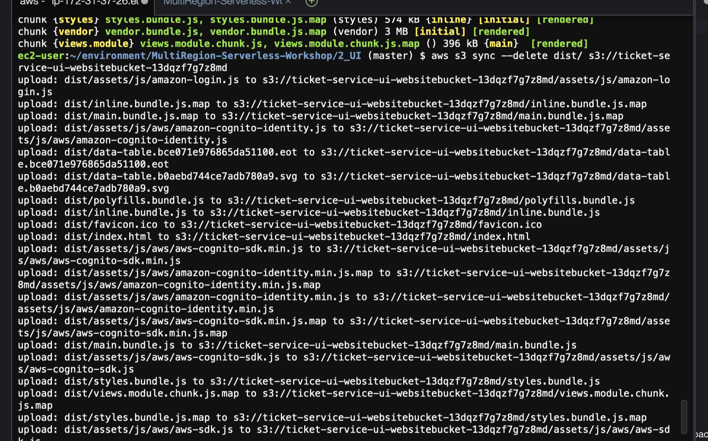

**Figure 38:** Uploading the UI to S3 bucket

38. Go to Settings > Basic in the dropdown menu to update Facebook App Settings with CloudFront URL for App Domains and Privacy Policy URL

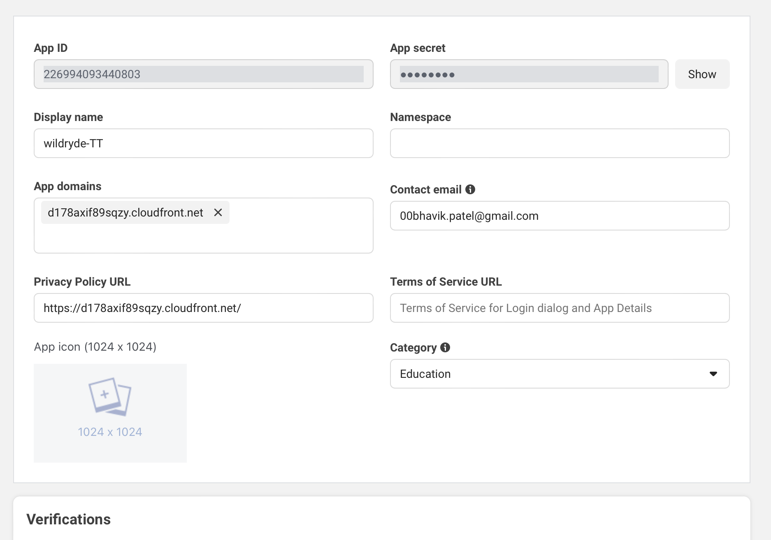

**Figure 39:** Updating Application Settings

39. Using the CloudFront URL to Access the Ticket System Console.

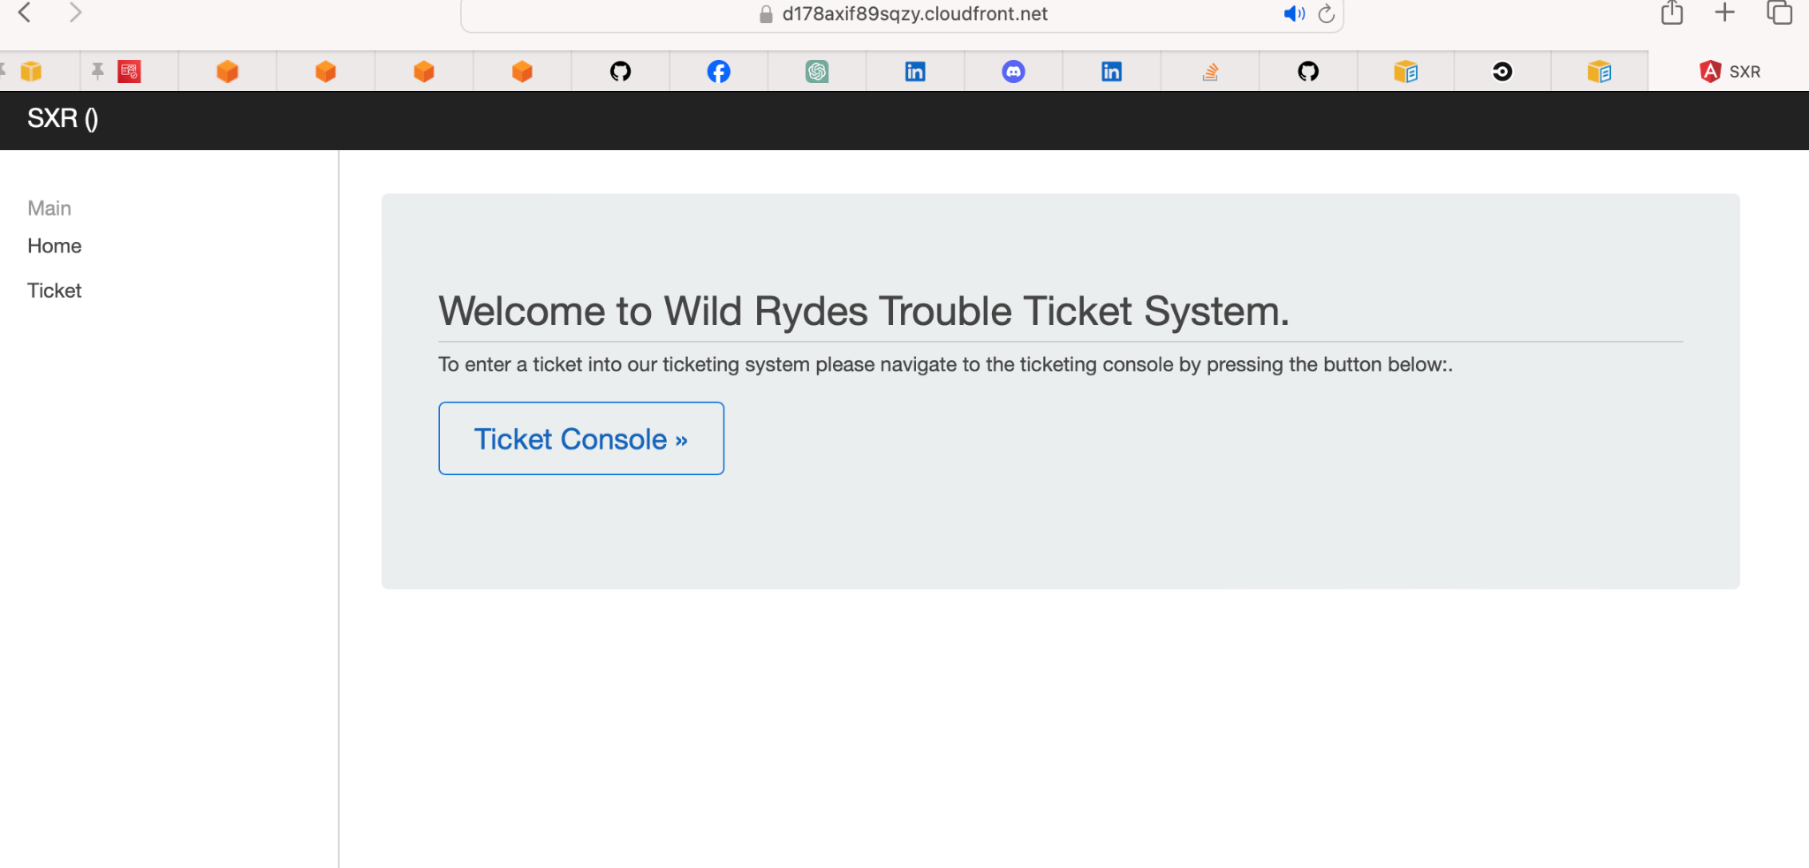

**Figure 40:** Verifying Application Access

40. Using Facebook Authentication to Log In and Access the Ticket System Console

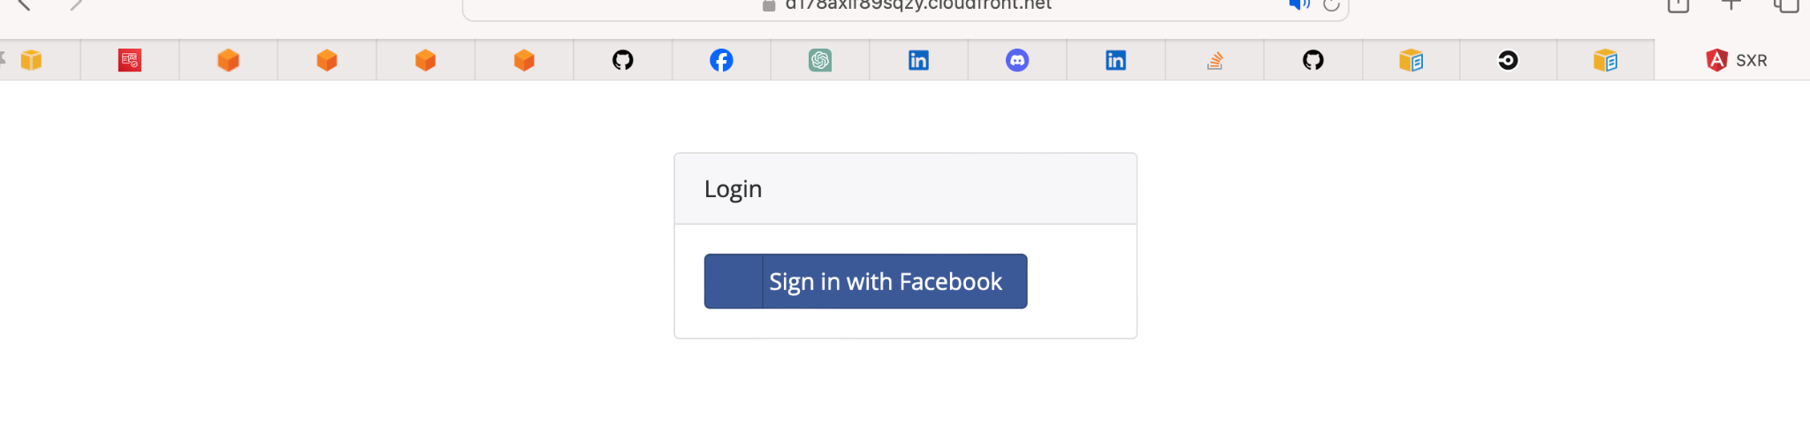

**FIgure 41:**  Signing In with Facebook

41. Notification for the Ticket System Console stating that the domain registration was successful

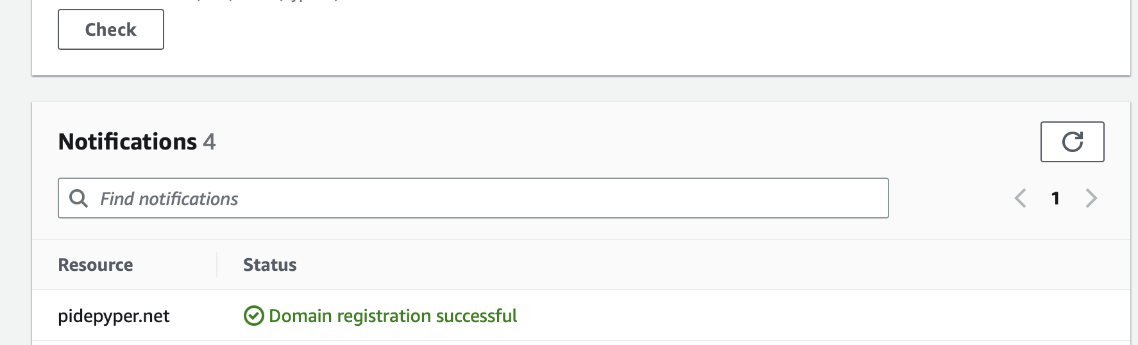

**Figure 42:** Notification indicating the status

42. Requesting a Public Certificate for the domain

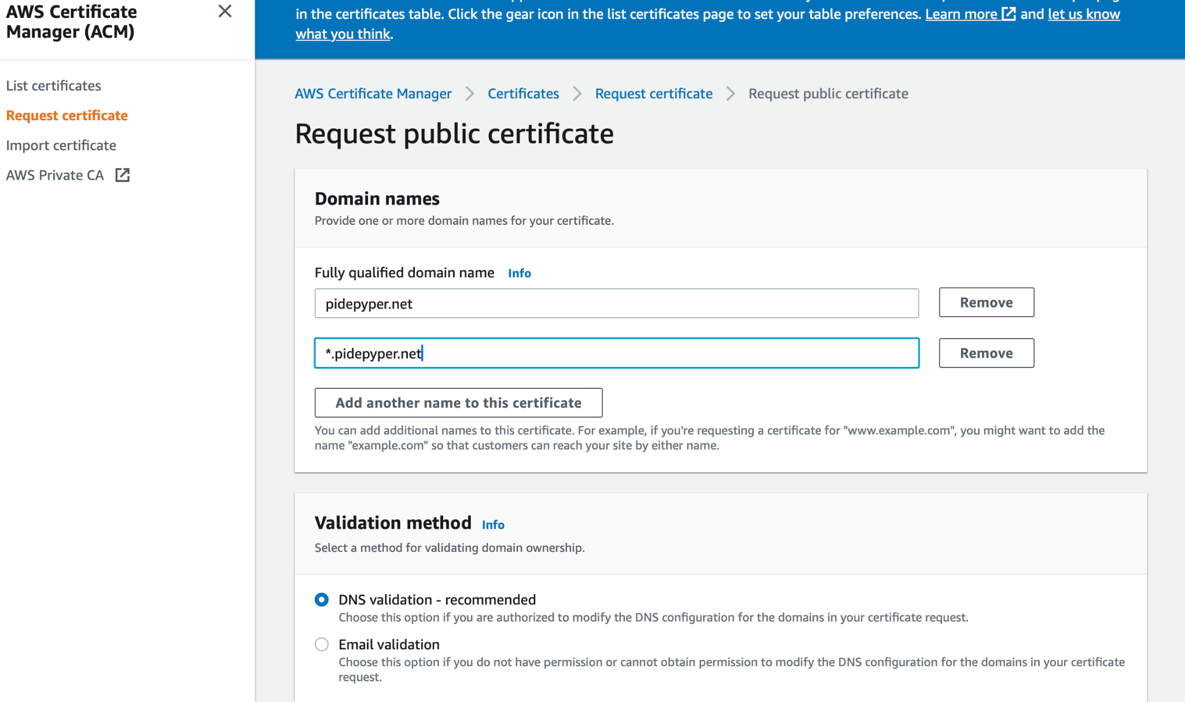

**Figure 43:** SSL/TLS Certificate Configuration

43. Providing the specifications that will be included in the certificate

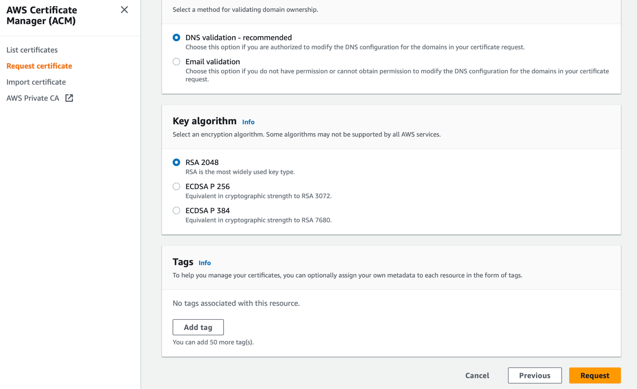

**Figure 44:** Certificate Configuration

44. Certificate availability

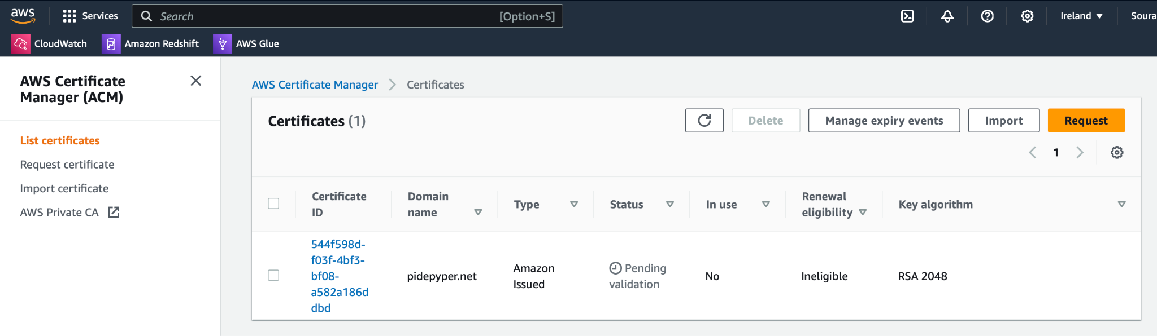

**Figure 45:** Display of the available certificate

45. Checking for the status of certificate

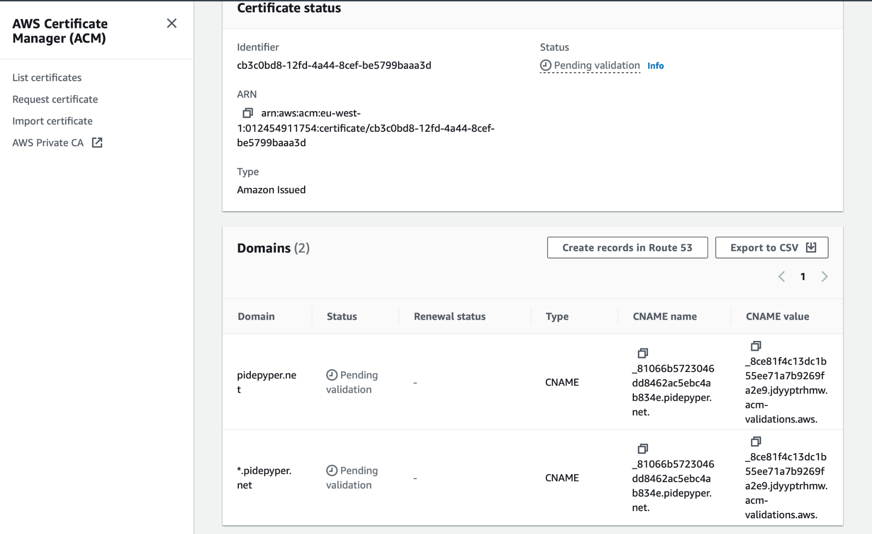

**Figure 46:** Certificate Status - Pending

46. The status of the certificate has been changed to "Issued," indicating that it has been effectively created and is prepared for use, providing secure encryption for the domain.

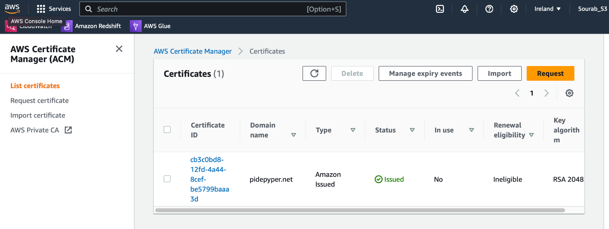

**Figure 47:** Certificate Status- Issued

47. DNS records inspected

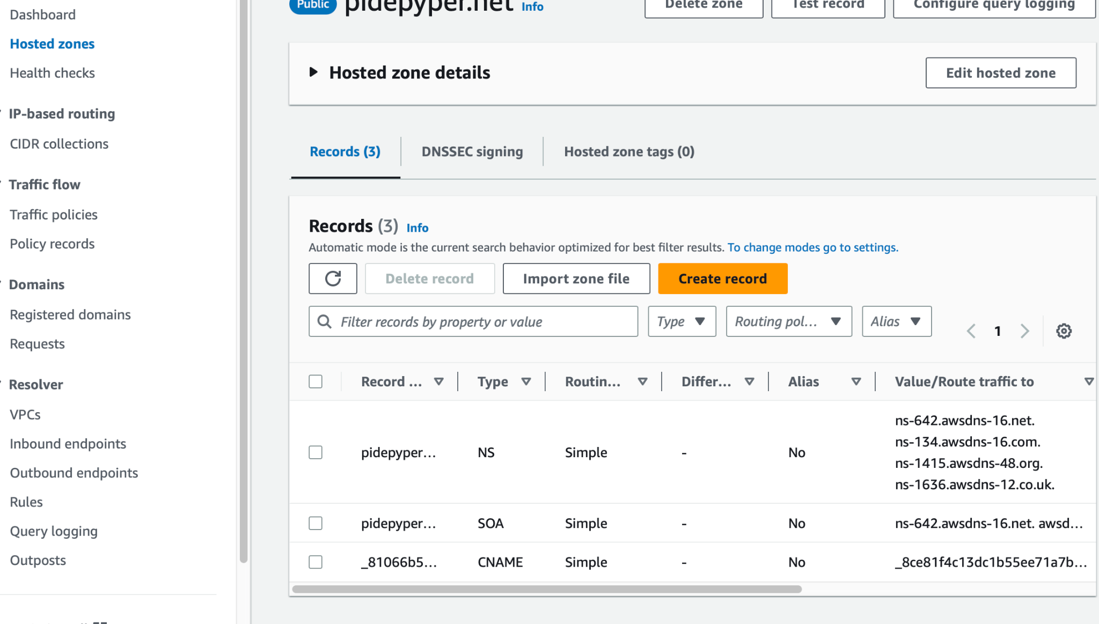

**Figure 48:** DNS records

48.Certificate created in singapore region

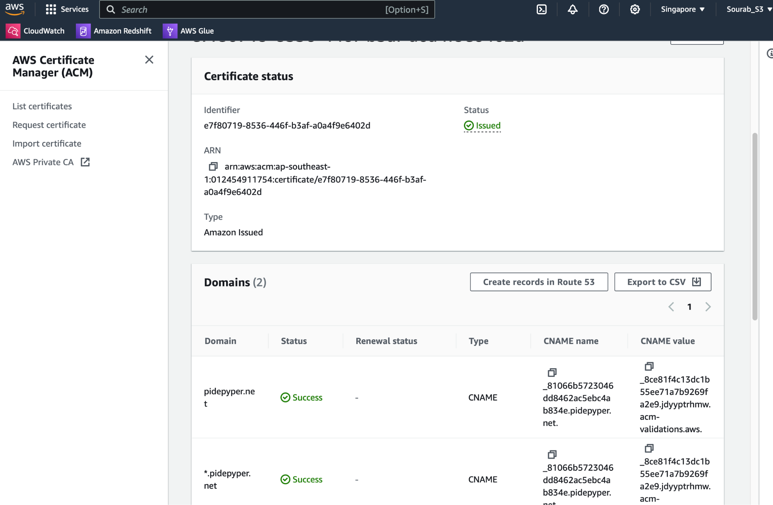

**Figure 49:** Domain Status Check

49. Edited TTL to 60 seconds

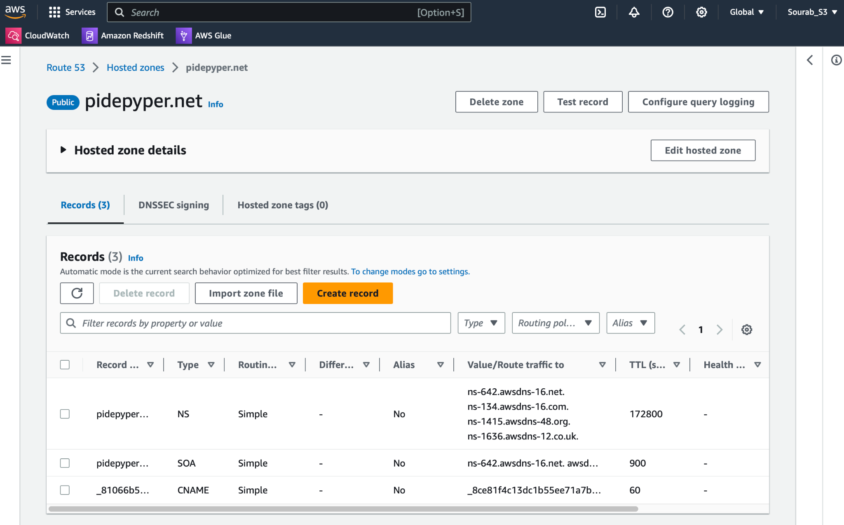

**Figure 50:** Updating TTL

**50.** Configuring the End Point

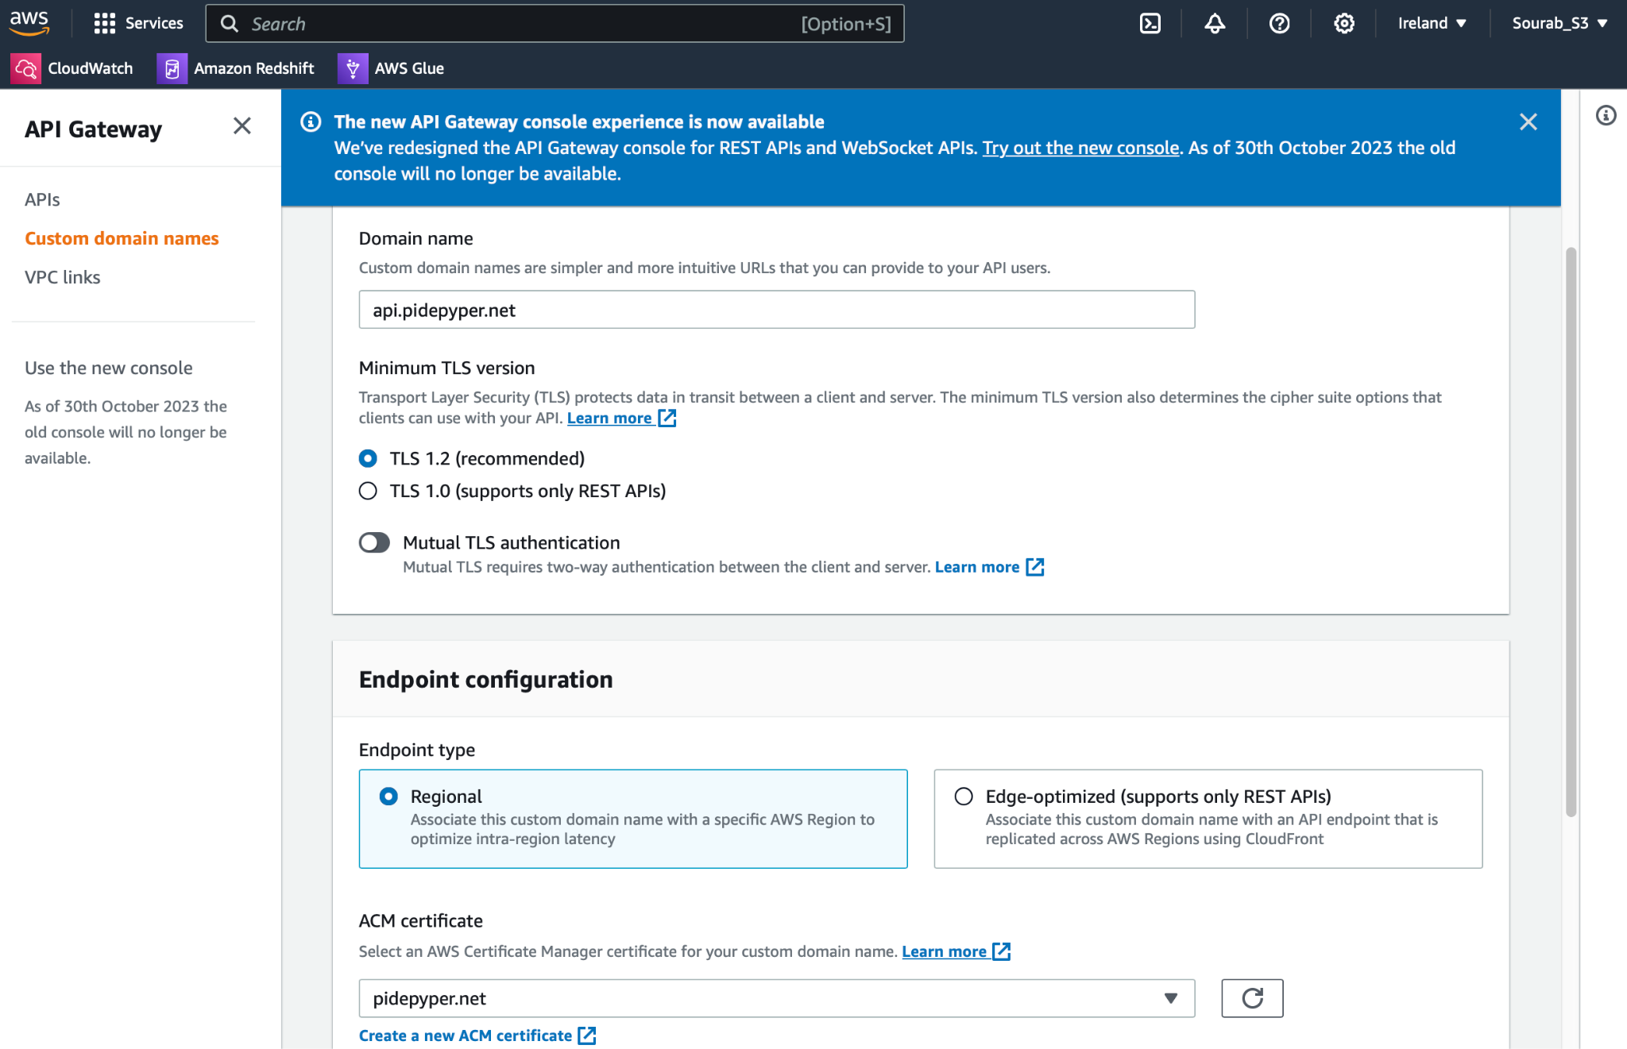

**Figure 51:** Endpoint Configuration

51. Reviewing the configuration for the API Endpoint

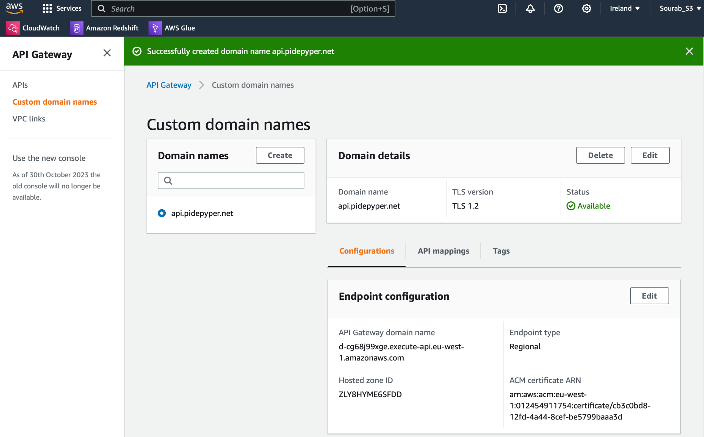

**Figure 52:** API Endpoint Configuration/Custom Domain Names

52. Creating custom subdomain for ireland

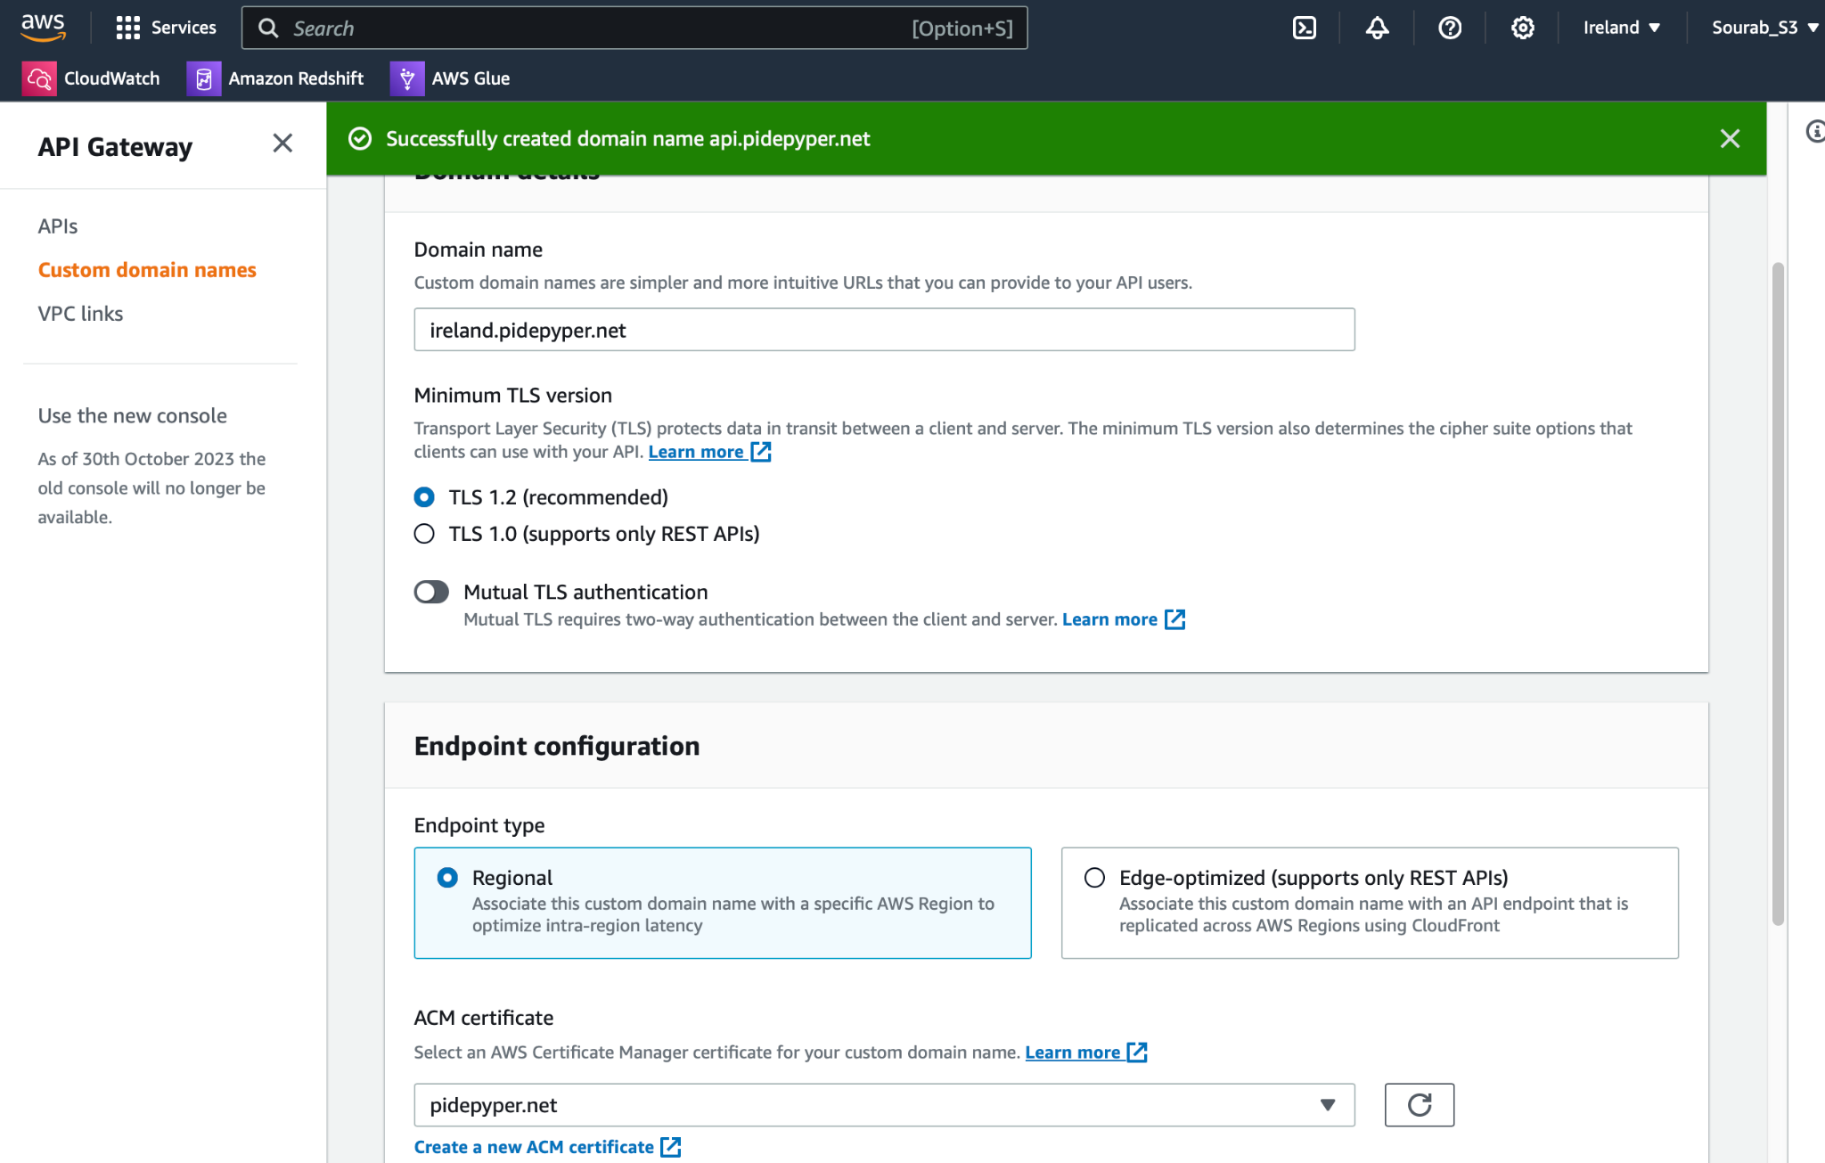

**Figure 53:** Creating a regional endpoint for Ireland Region

53.Successfully created endpoint for Ireland Subdomain

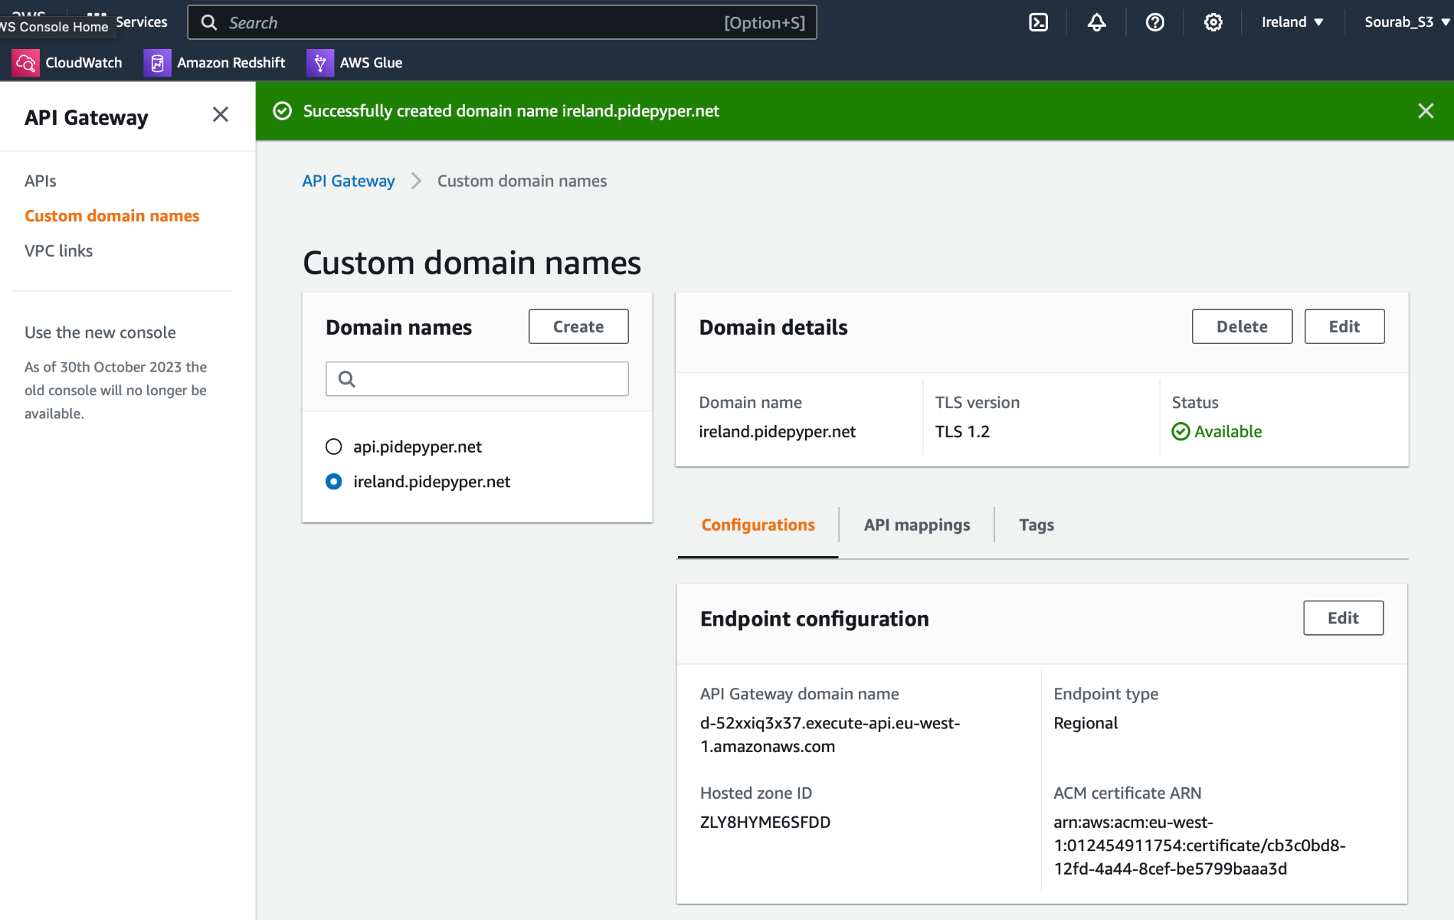

**Figure 54:** Subdomain for Ireland successfully created

54.Creating Subdomain for singapore

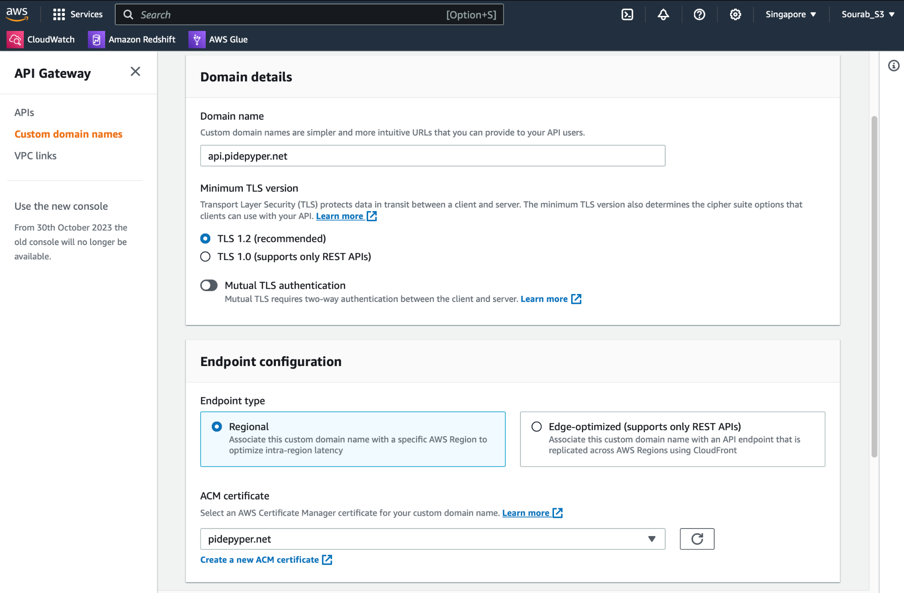

**Figure 55:** Creating Subdomain for Singapore

55. Successfully created endpoint for Ireland Subdomain

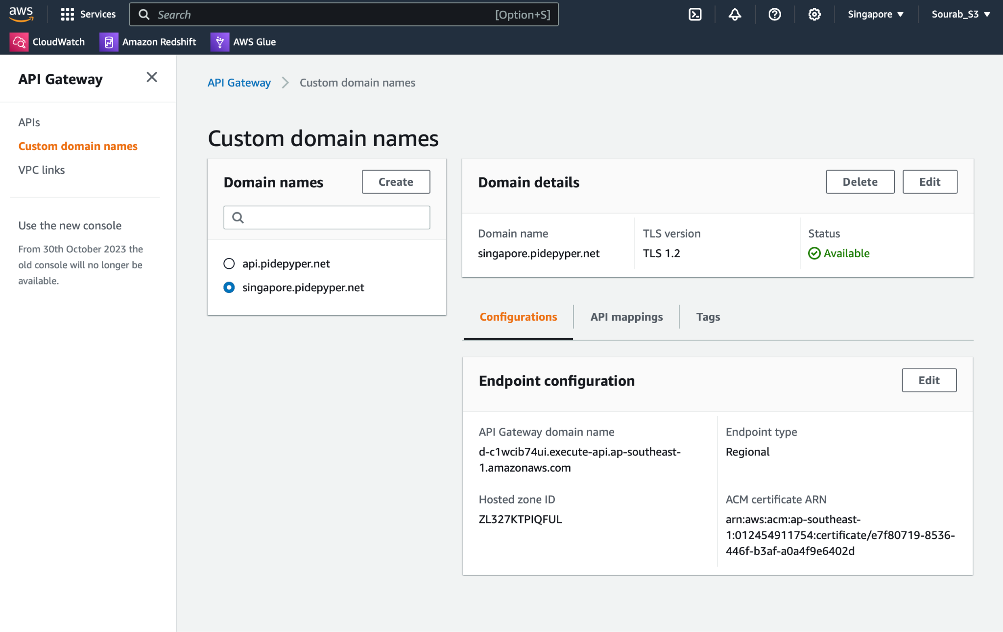

**Figure 56:** Subdomain for Singapore successfully created

56. Creating a new DNS record for Ireland Subdomain

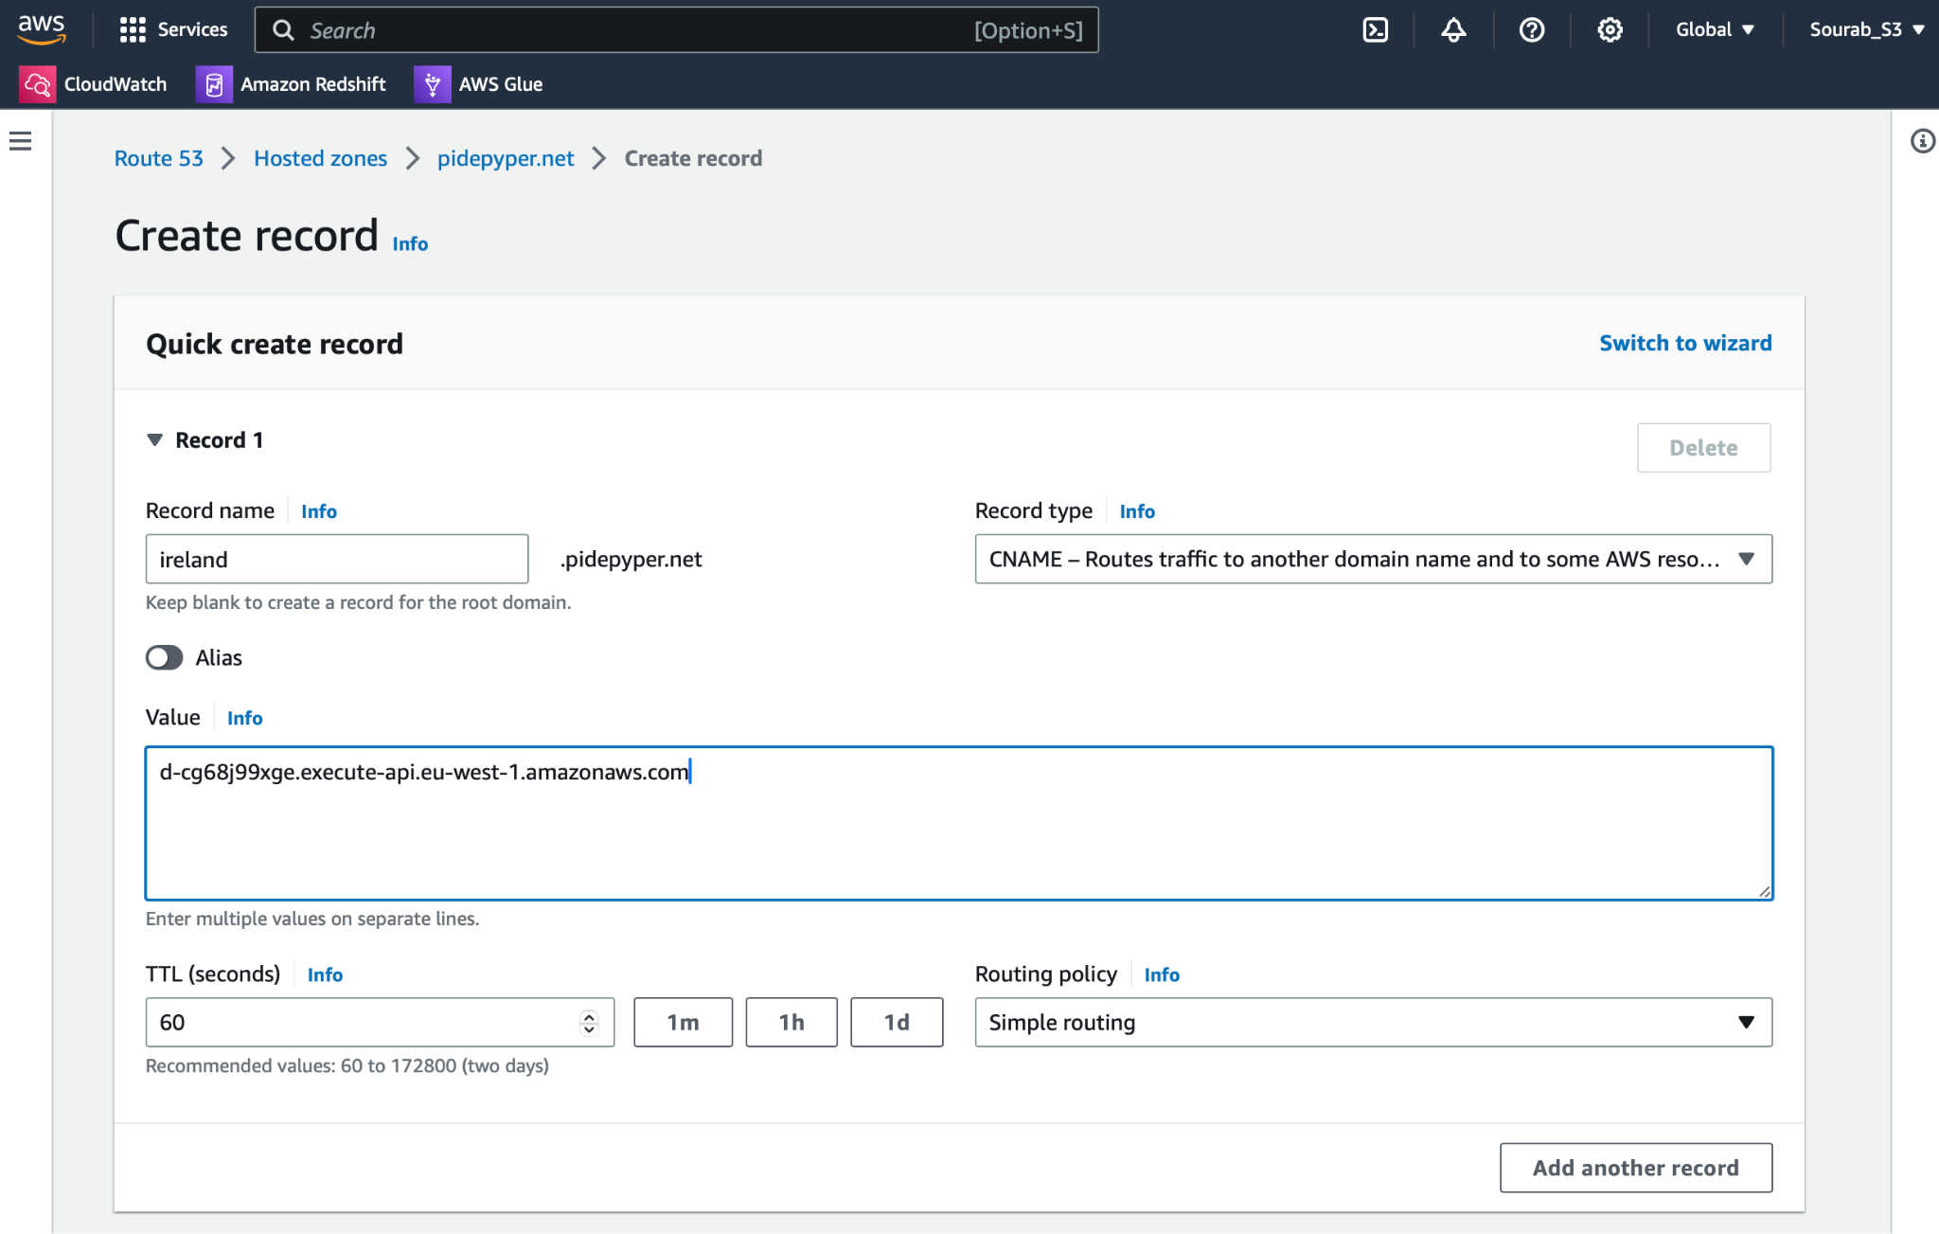

**Figure 57:** New DNS record for Ireland Subdomain

57.List of all the DNS Records

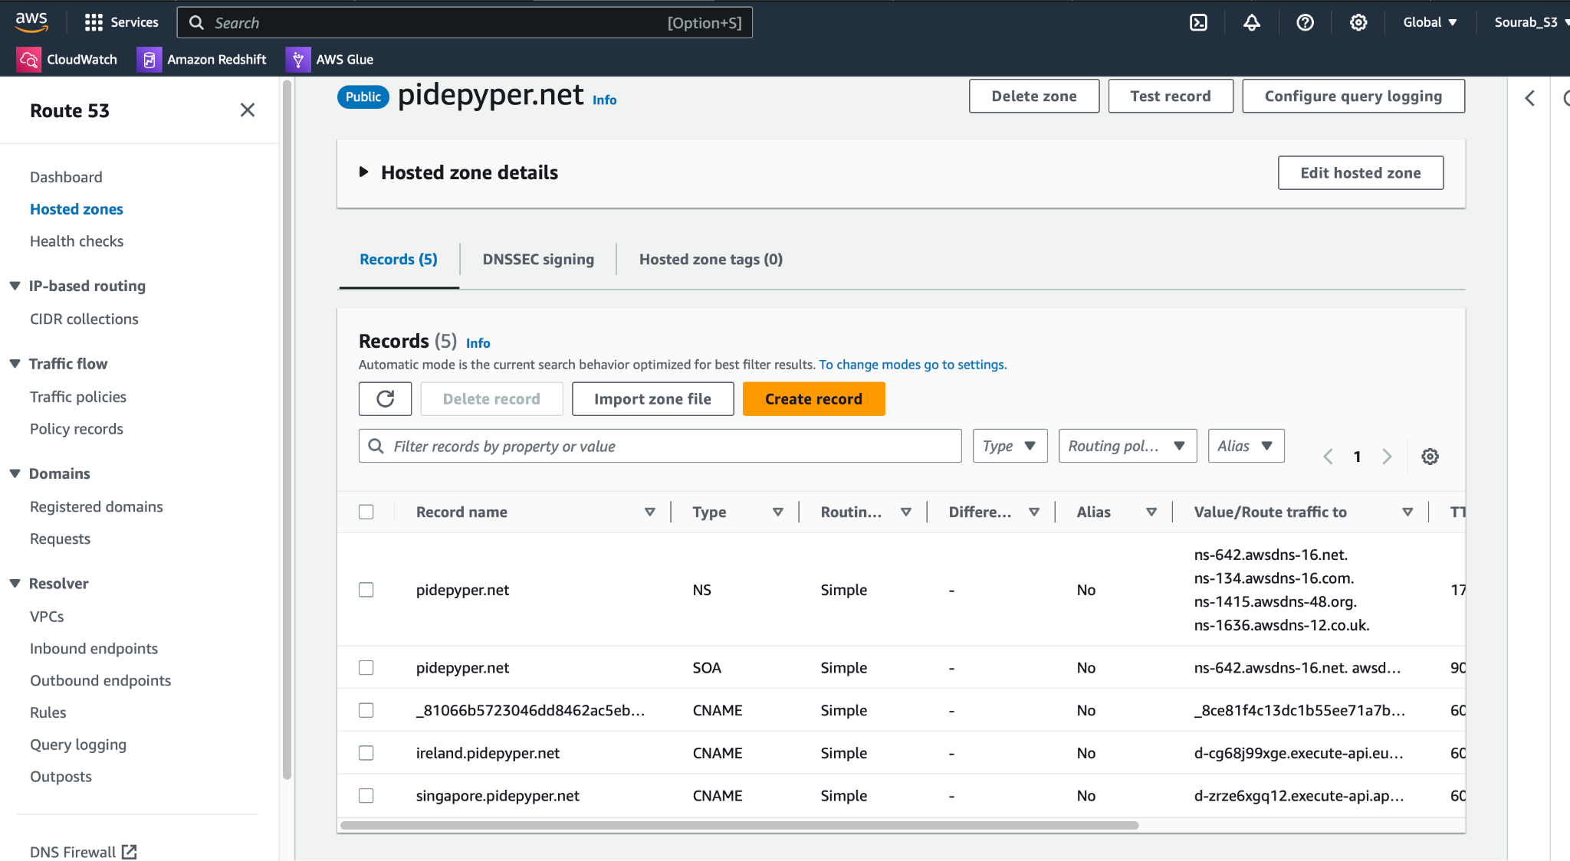

**Figure 58:** .List of all the DNS Records

58. Configuring Health Check for Ireland API

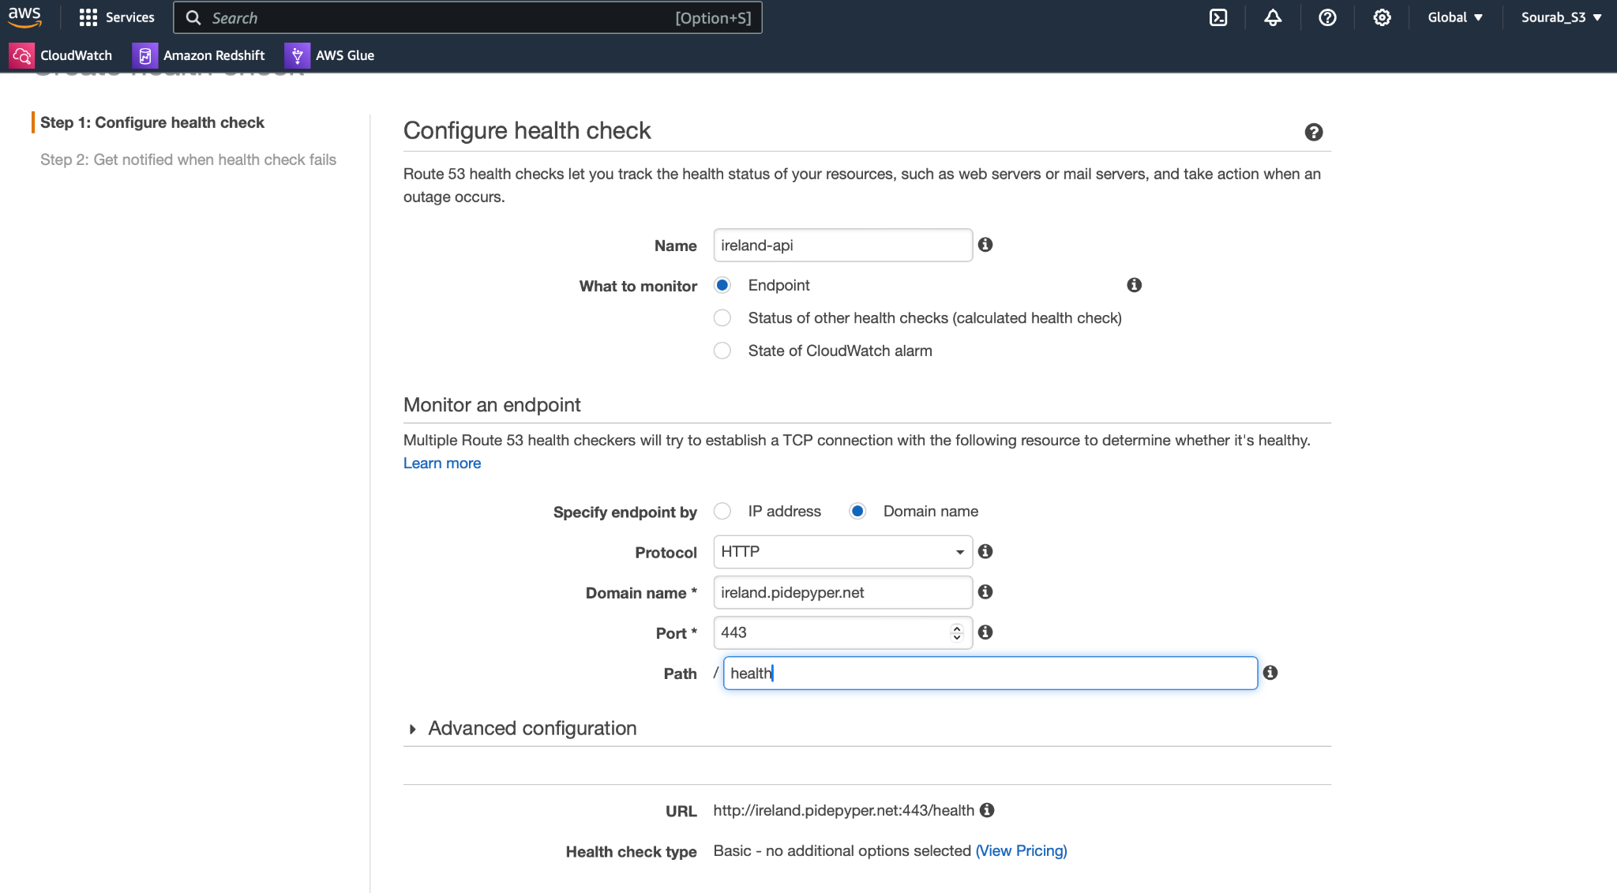

**Figure 59:** Configuring Health Check

59. Configuring Health Check for Ireland API and setting up the threshold as ‘2’

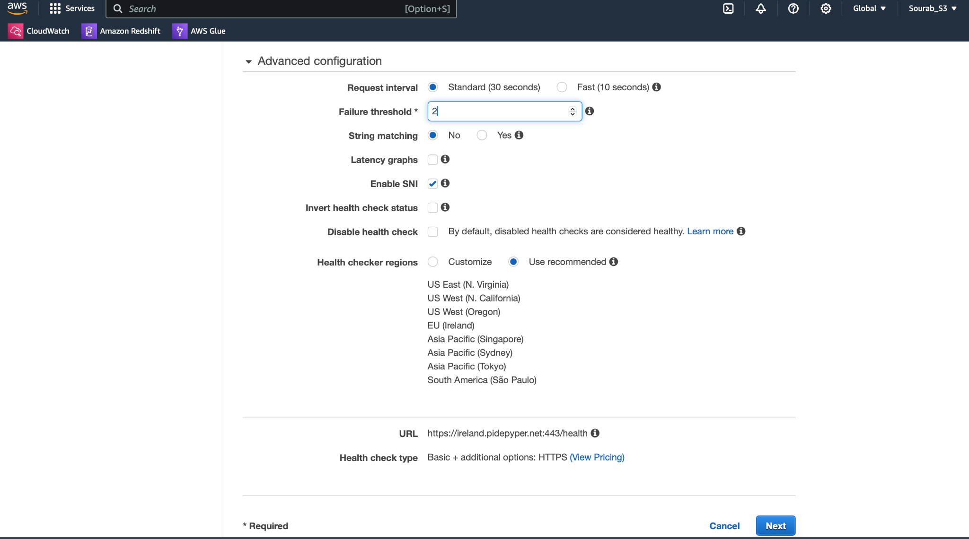

**Figure 60:** Setting up the threshold in health check

60. Setting up notifications for Health Check

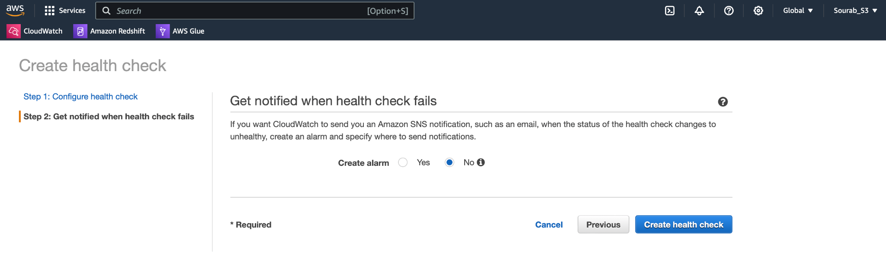

**Figure 61:** Health Check- Notifications

61.Configuring Health Check and setting failure threshold to ‘2’

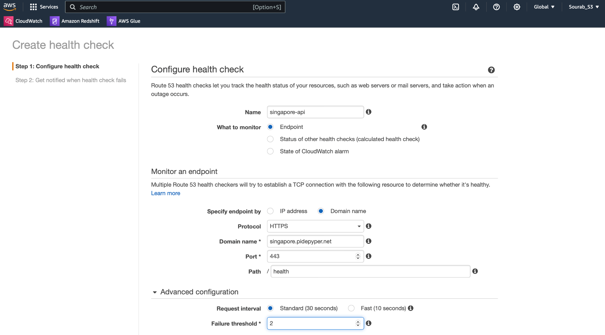

**Figure 62:** Configuring Health Check

62. Checking the Health Status of our two API regions

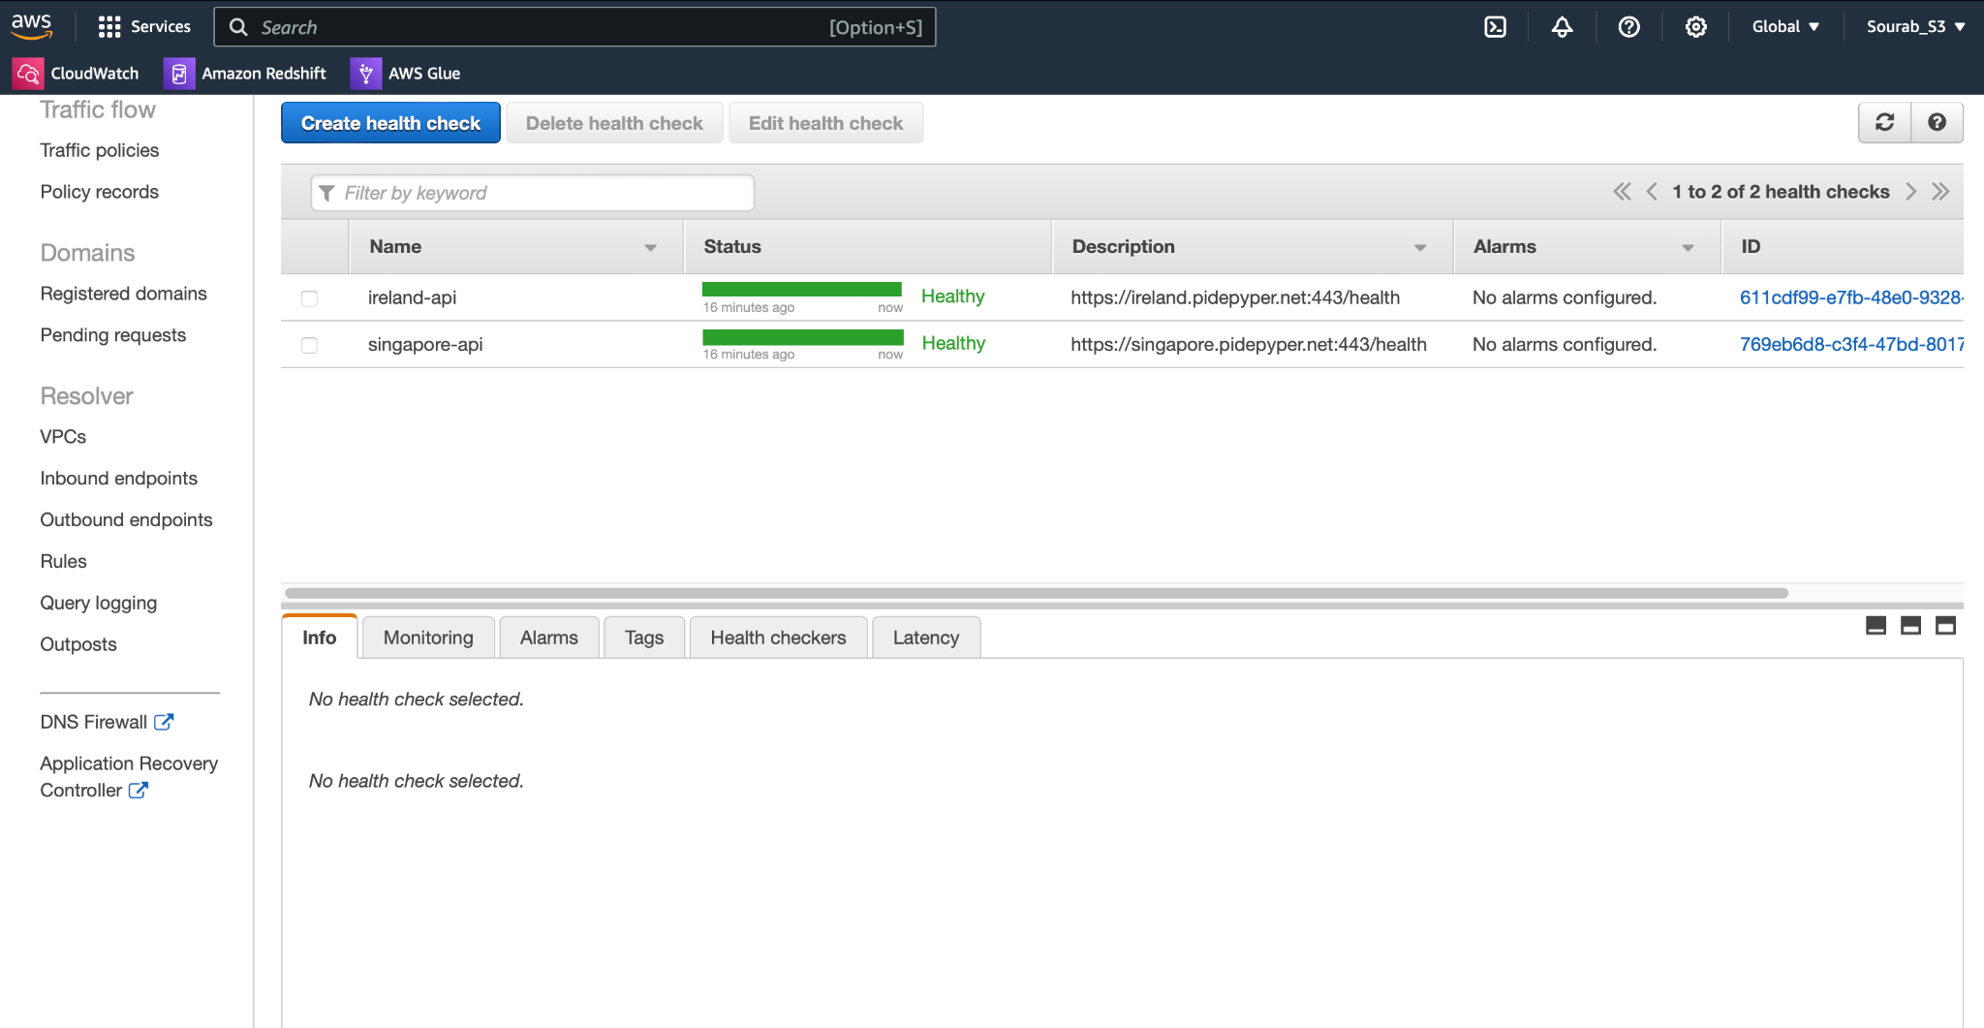

**Figure 63:** Checking Health Status

63. Creating record for pidepyper.net

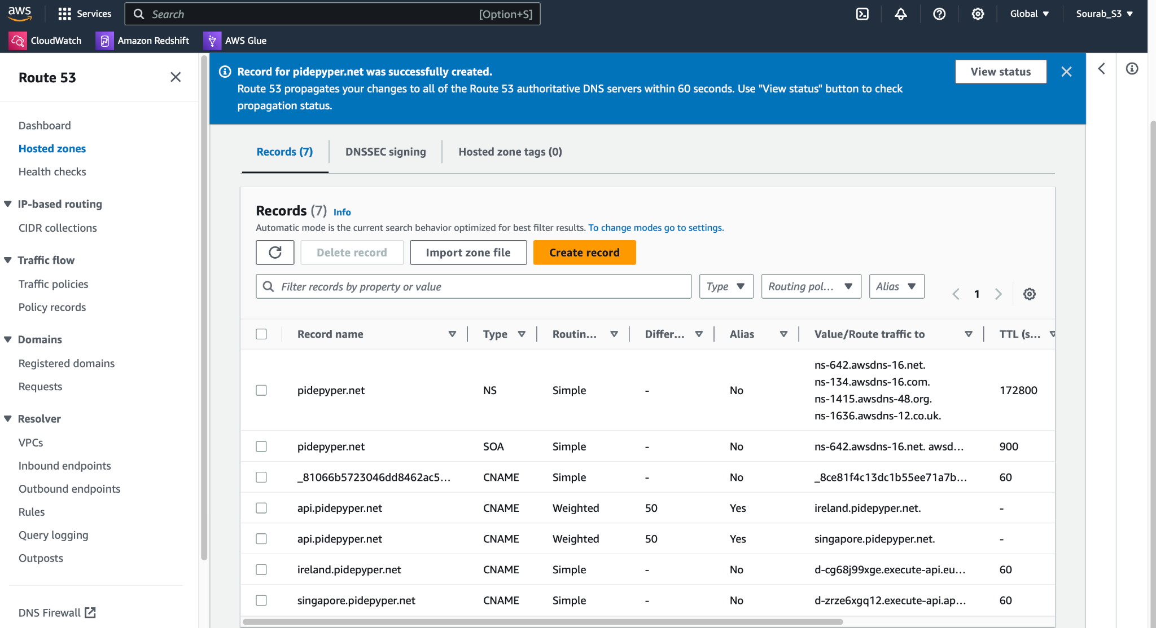

**Figure 64:** Record Successfully created

64. Output generated

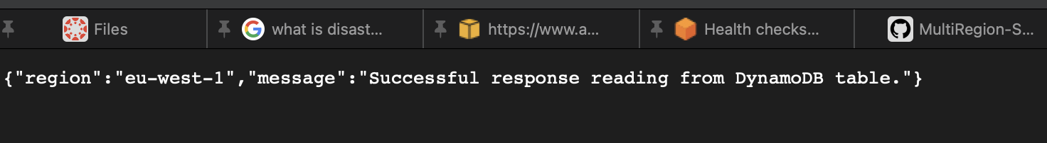

**Figure 65:** Visualizing record script

65. Modifying the “environment.ts” file to provide details

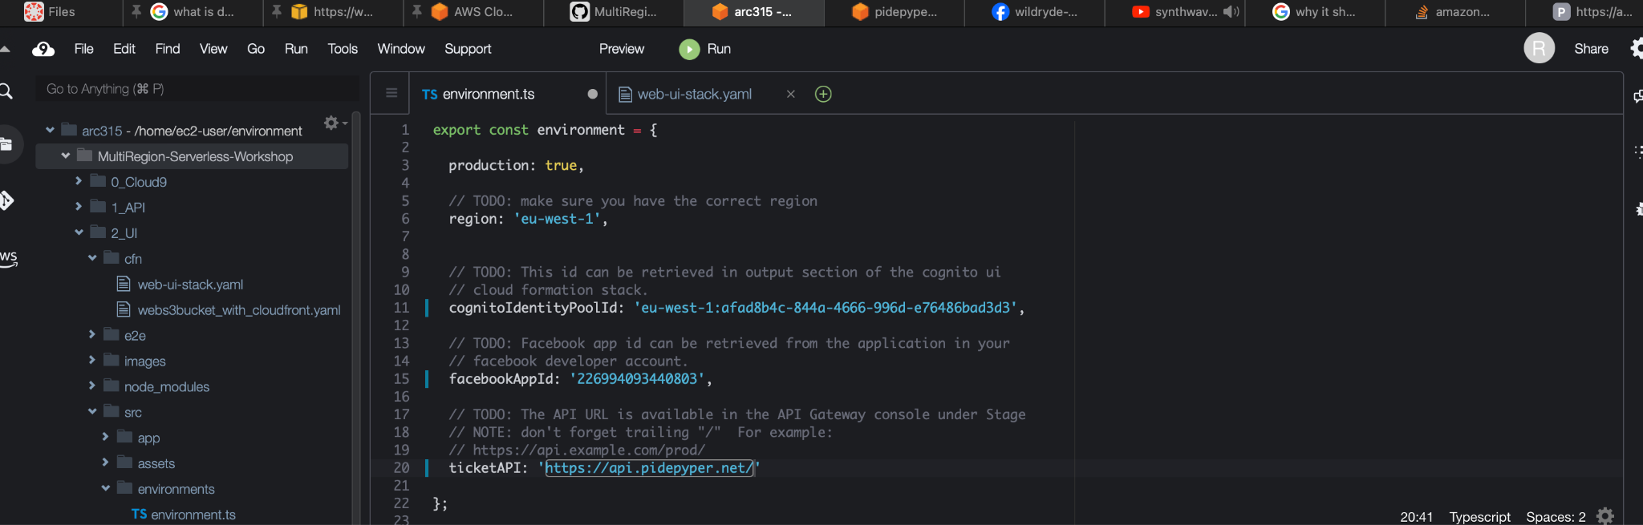

**Figure 66 :** Modifying the environment.ts file

66. Build Command to Build the Application.

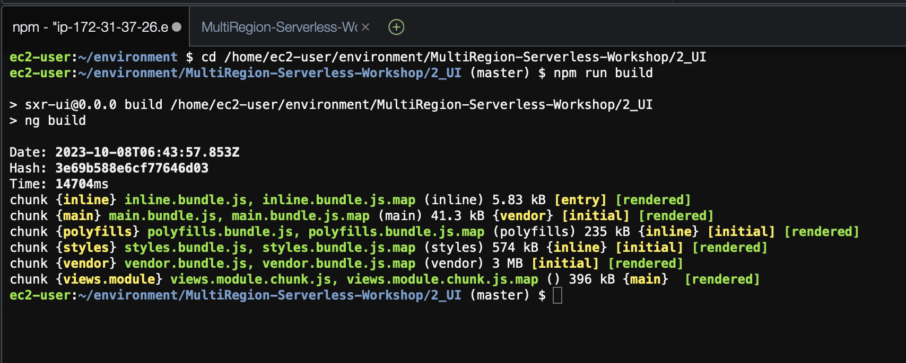

**Figure 67:** Successfully built the application

67. Uploading the /dist content to s3 buckets

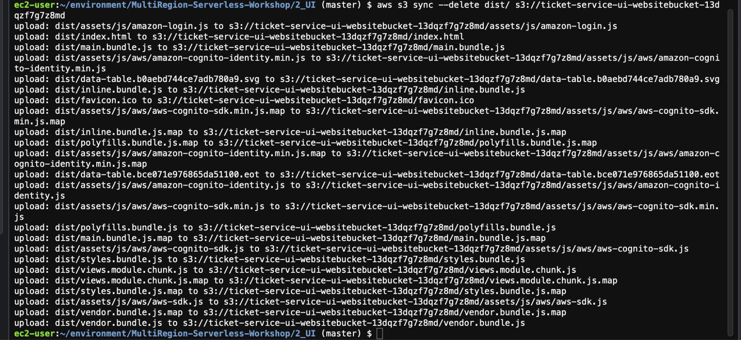

**Figure 68:**  Upload successful

68. GET request for Integration

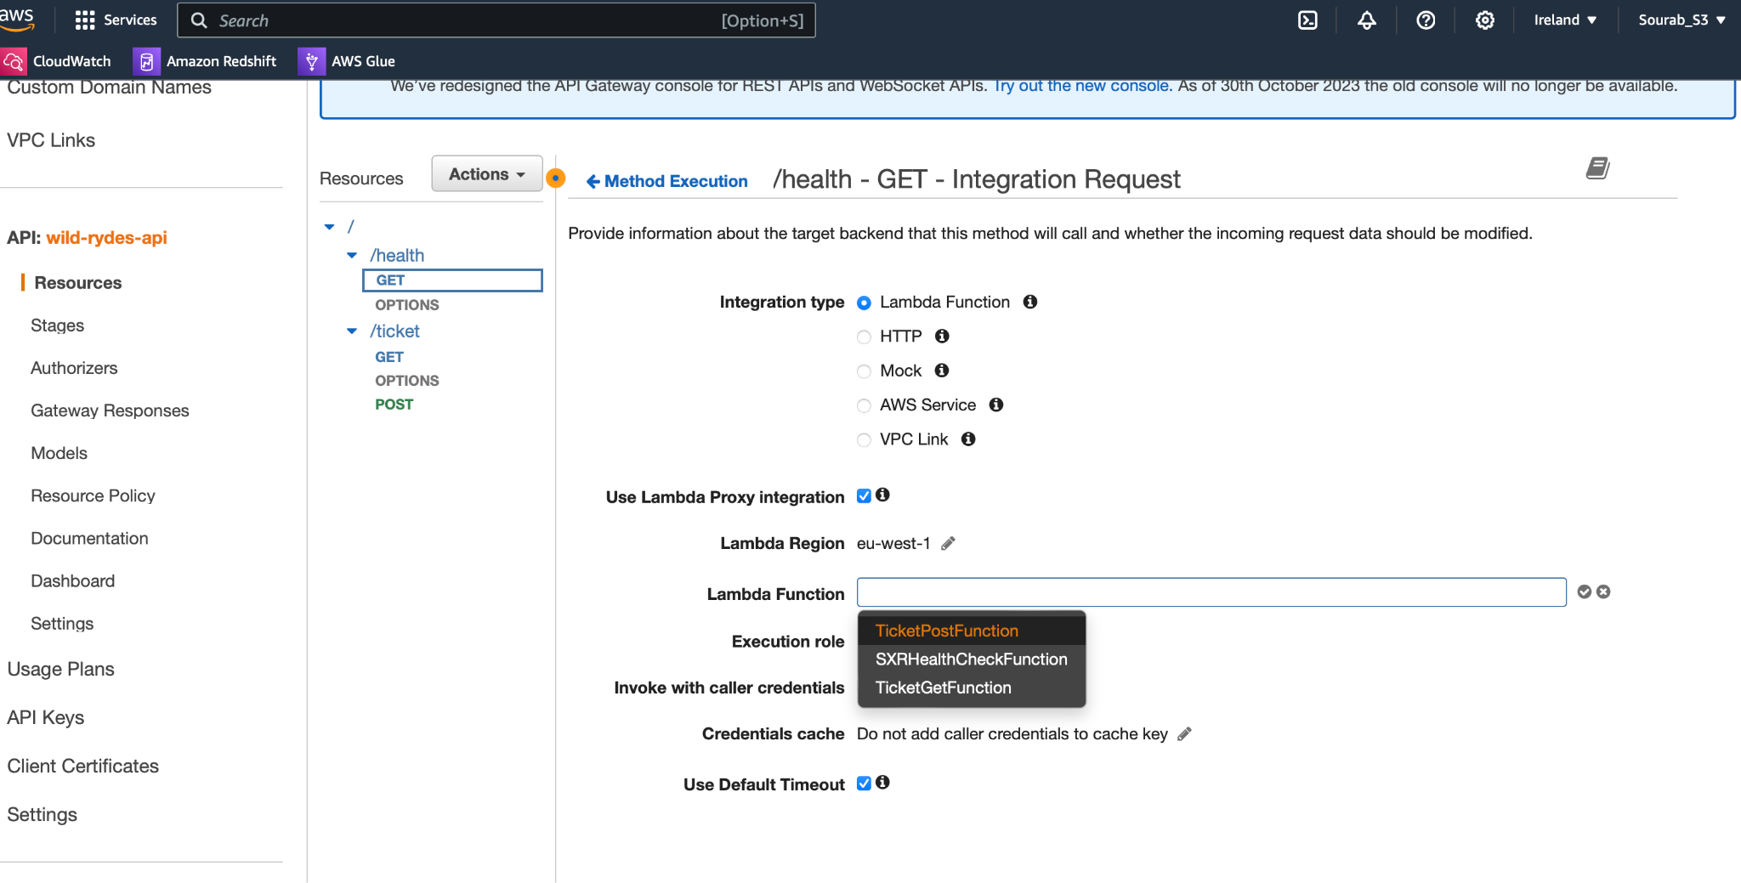

**Figure 69:** Integration- GET request.

69. Visualizing script of successful read operation in health check.

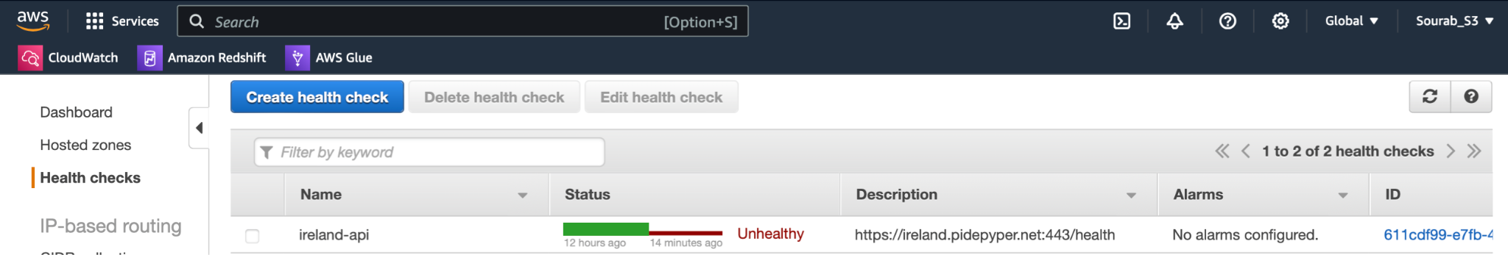

**Figure 70:** Visualizing script of successful read operation

**Link to Source Code repo:**

The code to our source code can be found : [Here](https://github.com/Yuti23/BigData-AWS--MultiRegion-Serverless)